VISUAL SENSING IN SPORTS MOTION CAPTURING

Hiroshi INABA^{*1} Tsuyoshi TAKI^{*1} Shinya MIYAZAKI^{*2} Junichi HASEGAWA^{*1}
Mitsuhiro KOEDA^{*3} and Kaoru KITAGAWA^{*3}

*1 School of Life System Science and Technology, Chukyo University
101 Tokodachi kaizu-cho Toyota, 470-0393 Japan
E-mail: {h-inaba,taki,hasegawa}@life.chukyo-u.ac.jp

*2 School of Computer and Cognitive Sciences, Chukyo University
101 Tokodachi kaizu-cho Toyota, 470-0393 Japan
E-mail: miyazaki@sccs.chukyo-u.ac.jp

*3 School of Physical Education, Chukyo University
101 Tokodachi kaizu-cho Toyota, 470-0393 Japan
E-mail: {koeda,kit}@sass.chukyo-u.ac.jp

ABSTRACT

This paper realizes visualization of human body sensing for supporting sports motion analysis. In sports motion analysis, for example hitting or throwing a ball, kinesiological information such as electromyogram values are checked corresponding to human body motion action in video images. It is important for analysts to find influences among them. For example, analysts have to read the features in a graph of EMG and match them to each phase in a player's form. However, it is difficult to correspond on the time line, especially in short motions. Therefore, we present a method for generating a CG animation to observe both kinesiological information and motion form simultaneously. In the animation, several kinds of kinesiological information values are mapped onto corresponding parts of the human body with varied colors. The motion of three-dimensional human body model is constructed from video images or the motion capturing system. Kinesiological information is measured adjusting time with the motion capturing process. In this paper, a method of generating animation and experimental results are presented such as a golf swing, a bowling throwing motion and a cycling motion.

1. INTRODUCTION

Three-dimensional computer graphics (3DCG) is a powerful visualization tool to grasp invisible features in analyzing numerical data. It is actively applied to various kinds of fields such as industry, medicine, chemistry, and so on [1-3]. The sport field is one of them, which is our research purpose [4].
In the motion analysis, electromyogram (EMG) or foot pressure is used as kinesiological information corresponding to motion forms. It is important for the analyst to find influences among them. However, sensing information is individually processed. It has been one of the professional skills in integrating them. For example, analysts have to read the features in a graph of EMG and match them to each phase in a player's form. However, it is difficult to correspond on the time line when motion occurs in a short time. That has been pointed out as a serious problem by analysts. Information mapping by using 3DCG is expected to evolve their environment. It gives a solution to understand sensing information corresponding to motion animation of players in video images.
In this paper, we present a method for generating a CG animation to observe both kinesiological information and motion form simultaneously. In the animation, several kinds of kinesiological information values are mapped onto the corresponding part of human body with varied colors. The motion of three-dimensional human body model is constructed from video images or the motion capture system. Kinesiological information is measured adjusting time with the motion capturing process. In the following sections, a method of generating animation and experimental results are presented such as a golf swing motion, a bowling throwing motion and a cycling motion. In the cycling motion, we applied our visualization method to real training.

2. GENERATION OF ANIMATION

In this section, procedures of animation generation are explained, as an example, in the case applying to a golf swing. Here, EMG and foot pressure are used as kinesiological information.

2.1 Overview of processing procedures

Figure 1 shows an overview of processing procedures for generating the animation. A couple of video images are taken from different vertical directions and some kinesiological information is recorded simultaneously, beforehand. The detail procedure is as follows.

- Extraction of corresponding feature points from the same frame of two video images
- Generation of a three-dimensional human body model using these points obtained by process 1
- Mapping of kinesiological information onto the human body model
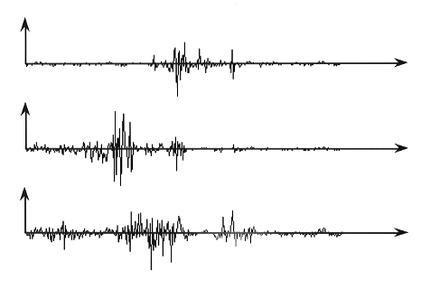
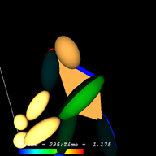
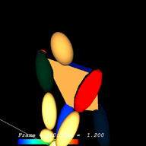
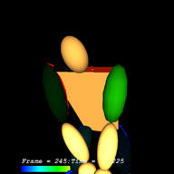
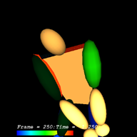
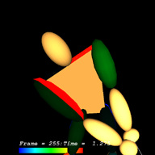
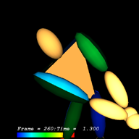
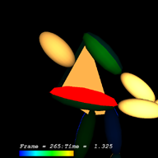
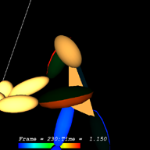
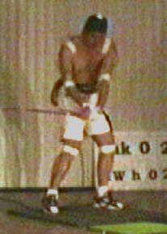
Fig. 1 Overview of processing procedures.
Information mapped human body model
Generation of 3D animation
Time synchronization
Kinesiological information
Video images
Captured motion
Constructing human body model
Mapping information
2.2 Kinesiological information

EMG and foot pressure are used here as input kinesiological information. EMG is an electrical value which is recorded by inserting a needle electrode into a muscle or putting surface electrodes on human skin. It is generally used for understanding muscle activities. We measure EMG values by using surface electrodes.
Foot pressure reaction force value is recorded by using a pressure gauge that is placed under the foot. It is generally used for tracking the center of gravity movement of the human body. Both EMG and foot pressure consist of one-dimensional time sequential values.
Some other kinds of kinesiological information are also available such as eye tracking or brain waves, which can be measured during motion.

2.3 Generation of a human body model

Motion capturing has evolved in the field of motion analysis [5]. Its real-time motion tracking saves us from time-consuming jobs such as plotting points. However, a large location is needed for placing infrared cameras. So, we sometimes use video cameras for tracking motion [6, 7].
In the video camera method, some feature points such as elbow and knee joints are manually plotted from the same frame of two video images. In this case, a golf club head and ball are also plotted as feature points. Table 1 and Fig. 2 show the kinds of feature points for this case. We used the DLT method [8] for deciding the three dimensional coordinates of feature points.
Figure 3 shows an example of generated human body model. Body parts such as arms and legs are expressed as an ellipsoid which is located along the line segment between a pair of feature points. Only the torso is expressed by a quadrangle consisting of both sides of the shoulder and both sides of the waist, for grasping twist motion. The golf club and ball are expressed by a line segment and sphere, respectively.
Table 1 Extracted feature points.
1 | R fingertips | 13 | L toe
2 | R wrist | 14 | L ankle
3 | R elbow | 15 | L knee
4 | R shoulder | 16 | L hip
5 | L fingertips | 17 | Top
6 | L wrist | 18 | Chin
7 | L elbow | 19 | Neck
8 | L shoulder | 20 | Navel
9 | R toe | 21 | Grip
10 | R ankle | 22 | Ball
11 | R knee | 23 | Club head
12 | R hip
1
4
7
11
15
3
6
10
14
18
5
9
13
17
20
8
12
16
19
21
23
2
22
Fig. 2 Layout of feature points.

2.4 Mapping kinesiological information

Mapping information is useful for grasping the transition of numerical values, because visuability is available such as assignment of color variation or intensity variation that is easily understood visually.
Color variation is often used for expressing our feelings or situations in everyday life. In this case, color corresponds to muscle tension pressure. Therefore, we used the color red for high values of EMG and the color blue for low values (Fig. [4]). Figure 5 shows a result of color mapping according to EMG values. For the case that more than two EMG values are measured in a single body element, multiple colors are mapped onto the corresponding ellipsoid (upper arms in Fig. 5).
Two kinds of mapping colors, direct mapping and relative mapping are realized. In the direct mapping, one of end colors blue is assigned to zero of EMG value, and the other end color red is assigned to a manually given maximum value. It is suitable for watching direct EMG values as it is in an interested body element.
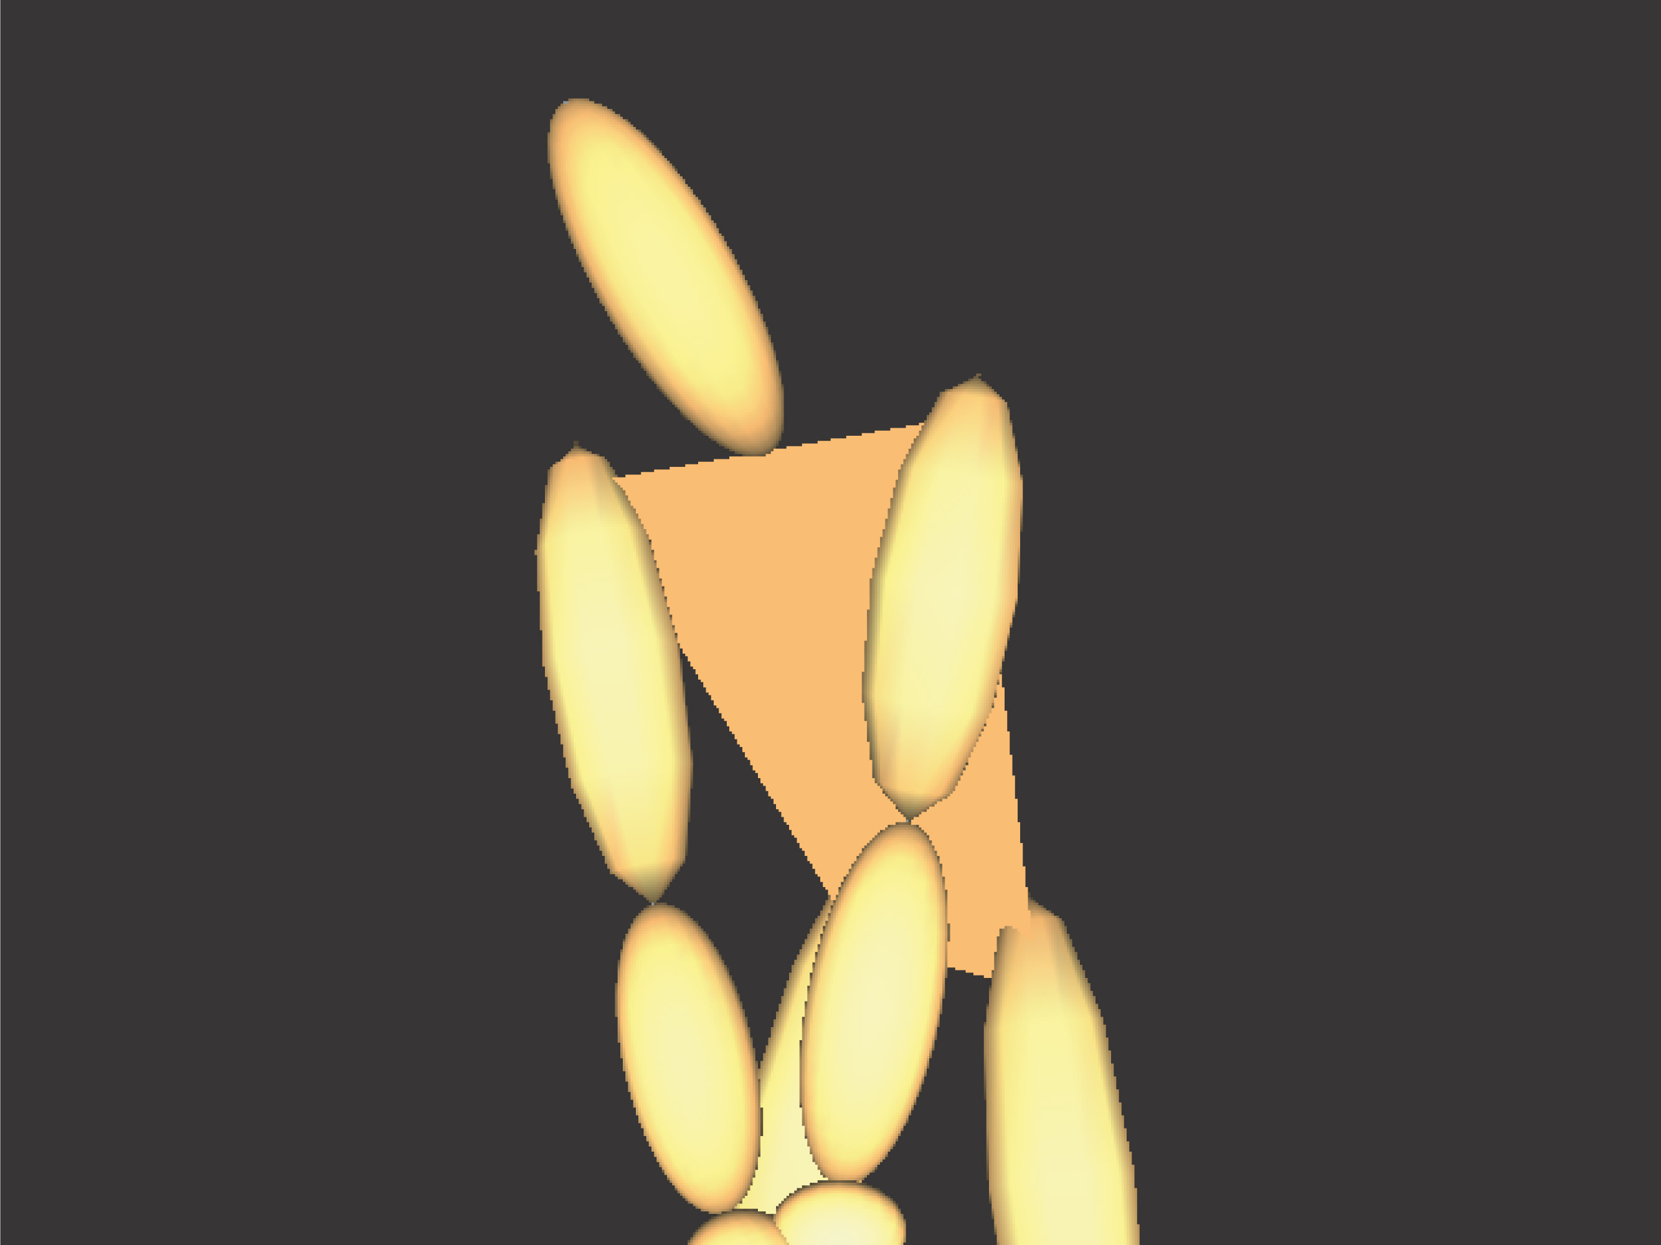
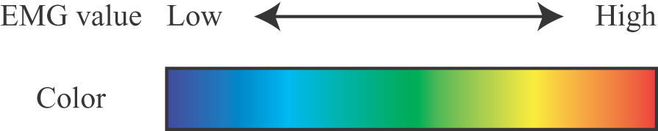
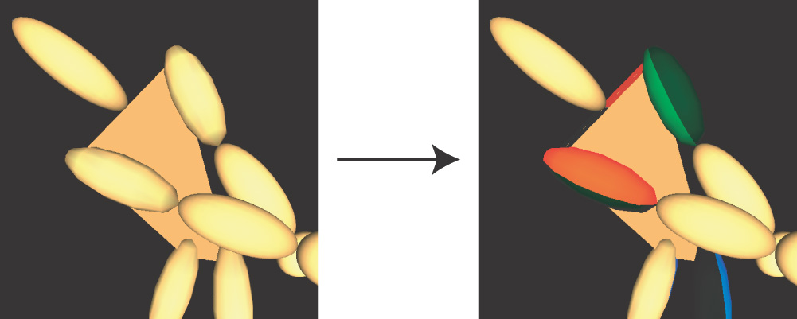
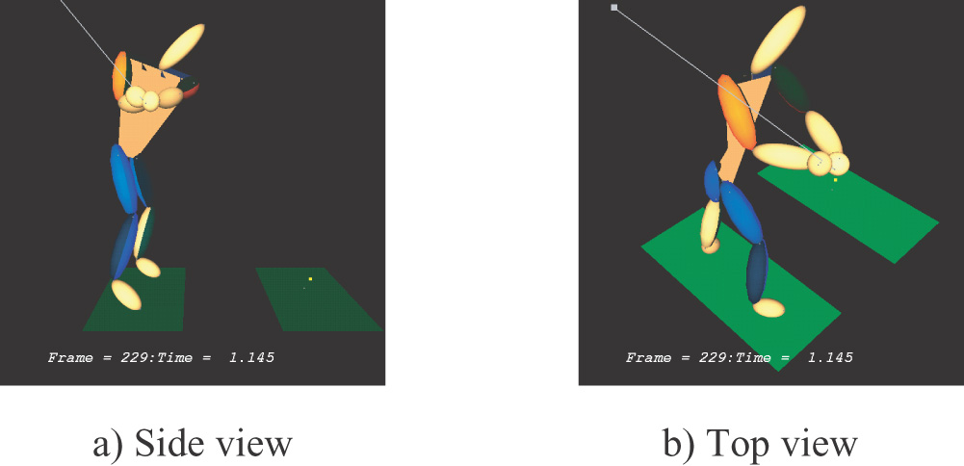
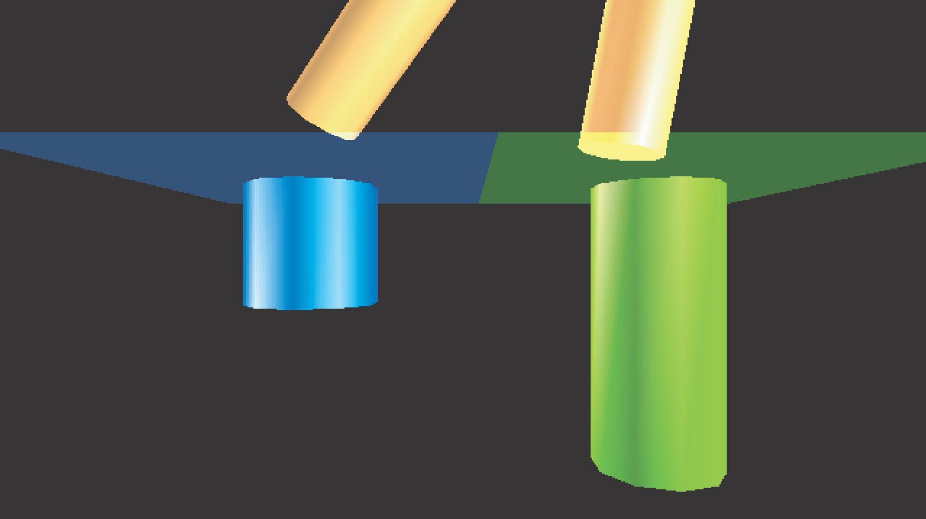
On the other hand, in the relative mapping, end colors red and blue are respectively assigned to the maximum and minimum numbers of all the EMG values measured through motion capturing. It is suitable for grasping distribution of EMG values in a whole body or transition of EMG values through whole motion.
Fig. 3 An example of generated human body model.

Fig. 4 Corresponding colors to EMG values.

Fig. 5 A result of mapping kinesiological information.

Fig. 6 Changing view in observation.

Fig. 7 Visualization of foot pressure.

An animation in Fig.1 is an example of relative mapping. High EMG values appear in the left upper arm in the beginning of down swing, and they change to the right upper arm through the motion of hitting a ball. In real observation of mapped information, occlusion is avoidable by changing the view because the human body model is three dimensional and animation is generated in real time (Fig. 6).

3. EXPERIMENTS

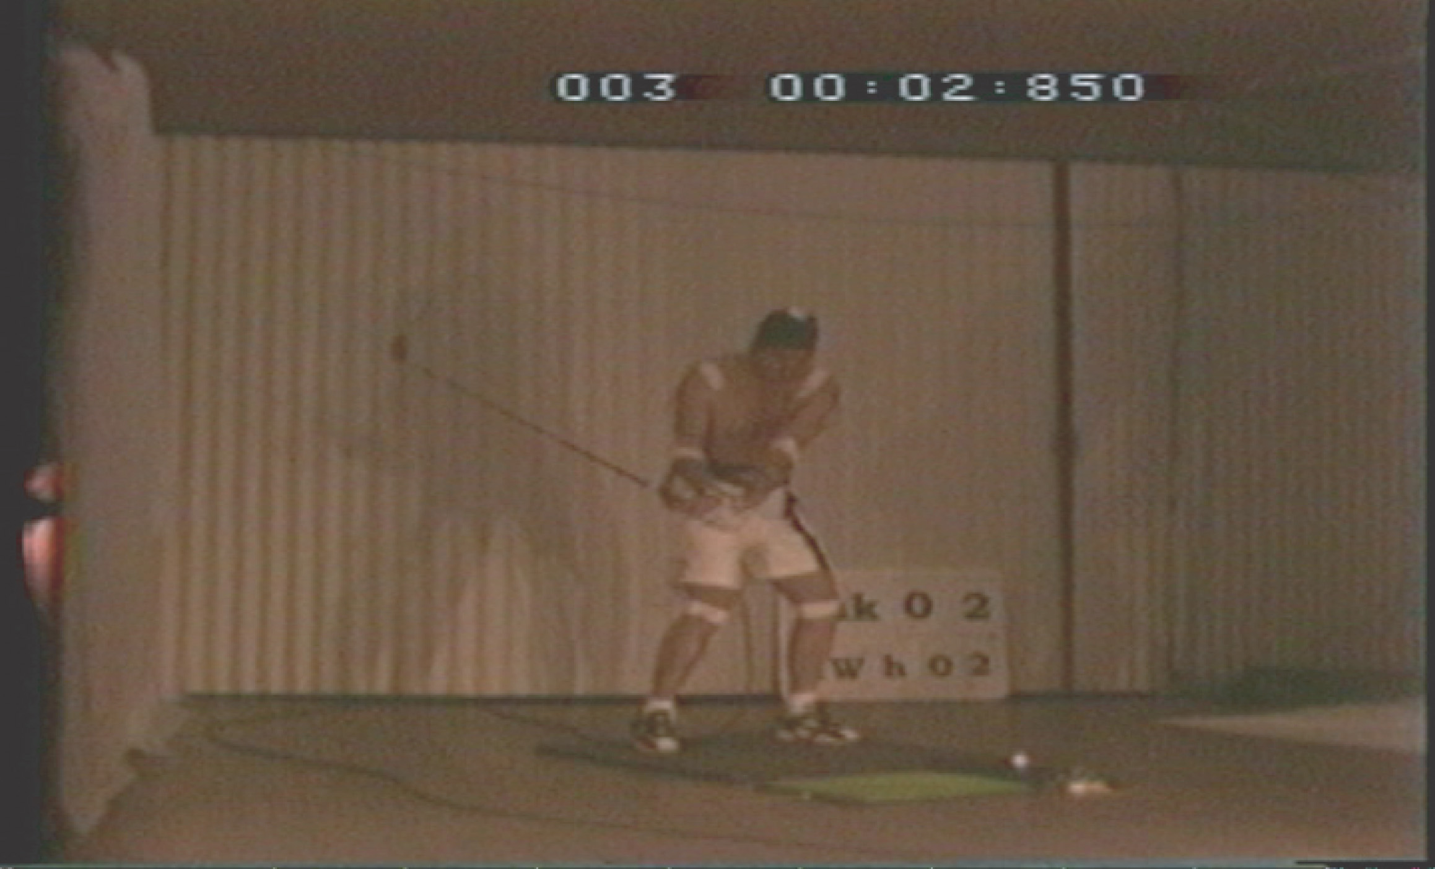
The proposed method is applied to golf swings, the throwing of a bowling ball, and runner's starting positions. Kinesiological information EMG is used for evaluating skills and individual differences among players, in all the experiments.
Fig. 8 A golf swing frame image captured by a high speed camera.

3.1 Golf swing application

In the golf swing application, the golf club head moves at high speed. To capture motion, we used a pair of high speed cameras that can record 200 frame images per second (Fig. 8). The specification of video image is 720x480 pixels, 8bit color/pixel. We selected EMG measurement positions which are shown in Table 2. These positions are considered to be important in golf swing motion. EMG values were measured by 1000 times per second and adjusted to the video frame rate by averaging some neighboring measurement values.
Table 2 EMG measurement points.
 | left side | right side
trapezius | x | x
biceps brachii | x | x
triceps brachii | x | x
rectus femoris | x | x
biceps femoris | x | x
tibialis anterior | x | x
peroneus tertius |  | x

In this experiment, the swings of two professional players are compared. Figure 9 shows two image sequences of golf swings in 0.05 second intervals. The moment of ball impact is placed at 0.0 seconds. Both of them show EMG transition according to the swing.
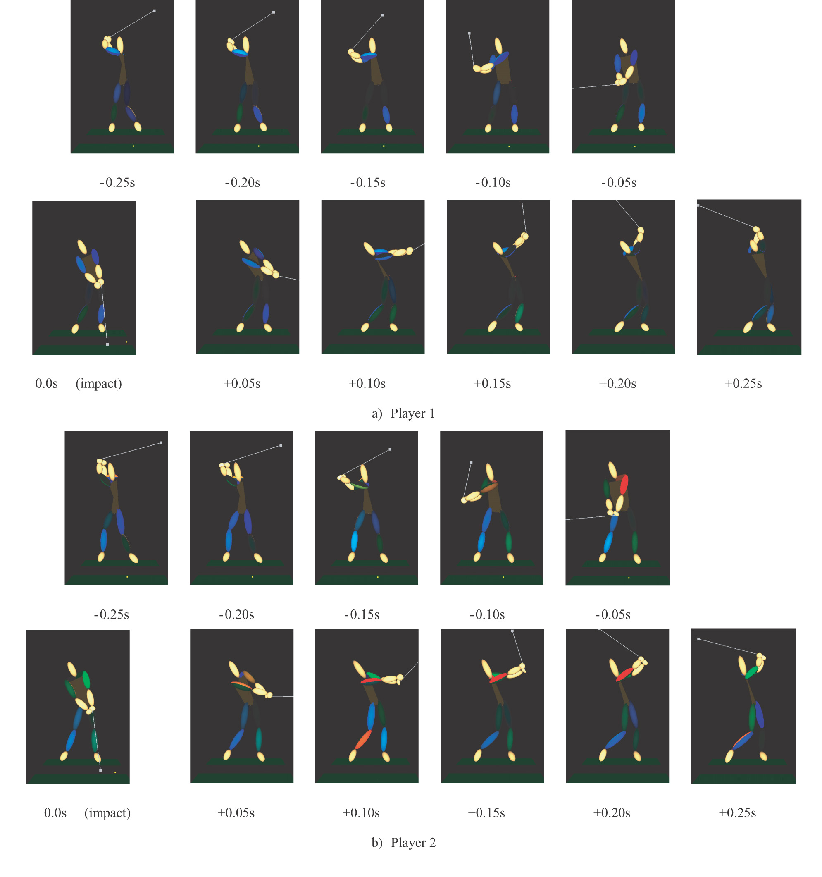
Player1's EMG values represent low activity in almost all muscles throughout the swing. On the other hand, in Player 2's EMG values, high values appear in the upper limbs throughout the swing, and also in lower limbs during follow-through.
Fig. 9 Comparing golf swings.

3.2 Bowl-throwing application

In the bowl-throwing application, we used digital video cameras (30 frames/sec.) for capturing video images which has higher portability than high speed cameras, because high speed motion capturing is not required in bowl-throwing.
In this experiment, two subjects, one professional and one amateur are compared. Figure 10 and 11 show EMG values in upper limbs, which are displayed in gradations of red. At the moment of releasing the ball, the professional player keeps high muscle activity in the upper arm. On the other hand the amateur player keeps high muscle activity in the forearm. Some other important information such as ball and form trace lines is shown in Fig. 10 and 11.

3.3 Cycling application

For this application, Motion Analysis Corp., MAC3D System was used. This is an optical motion capturing system constructed of twelve infrared cameras. The captured points were almost the same as in the golf swing application (Fig. 12). EMG values were measured in leg muscles (Fig. 13).
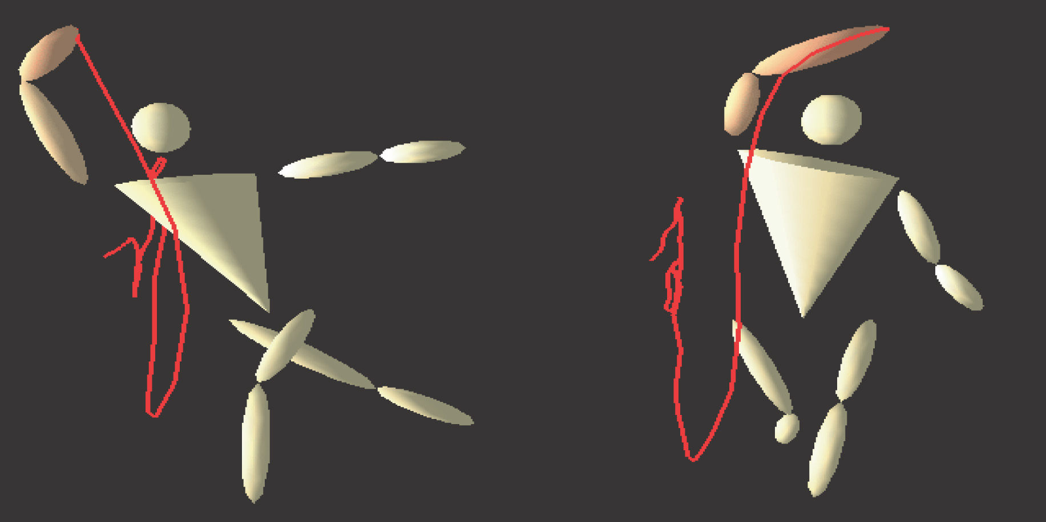
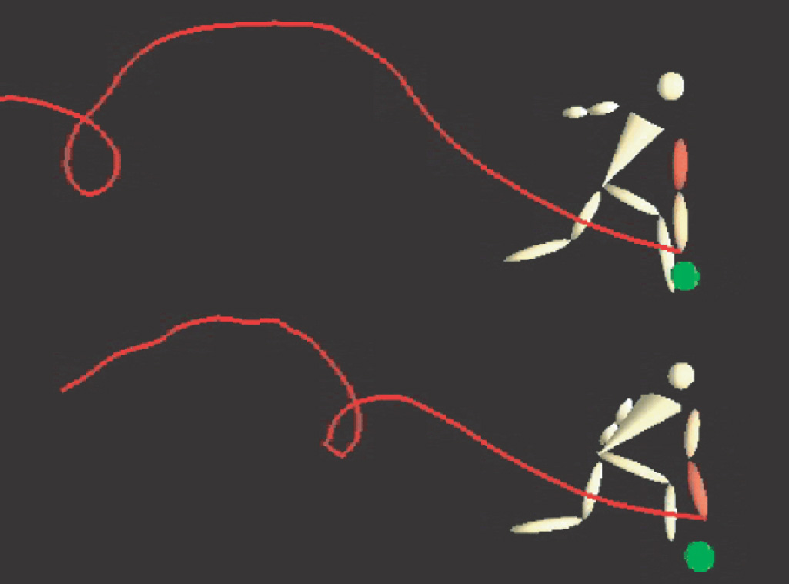
Fig. 14 shows a cycling training scene using our visualization method. The cyclist can see the captured results of the animation in Fig. 13 projected on the wall. In sports training with fixed positions, this process would be performed more effectively, because players can analyze results simultaneously corresponding to their movements while training.
Fig. 11 Comparison of EMG distribution at the final point of throwing between a professional (left) and amateur bowler (right).
Fig. 10 Comparison of EMG distribution at the release point of bowl-throwing between a professional (upper) and amateur bowler (lower).

3.4 Discussion

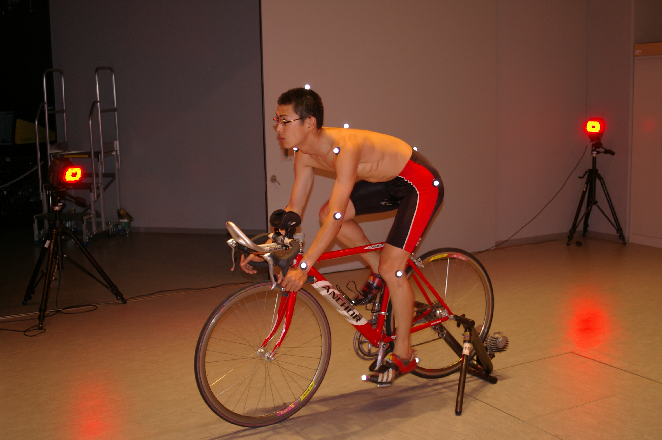
Experts in kinematics and golf and bowling coaches evaluated some animations generated by our method. They pointed out that these animations allow users to observe simultaneously the activity of plural muscles and the movement of the center of gravity. They can see it from any viewpoints easily and compare differences in motion among players. As a result, after evaluations, we now know that our animations can be used for understanding cooperative works among muscles and for evaluating the effects of coaching.
Fig. 12 Captured points in cycling motion. (White points on the human body represent markers for optical motion capturing system.)
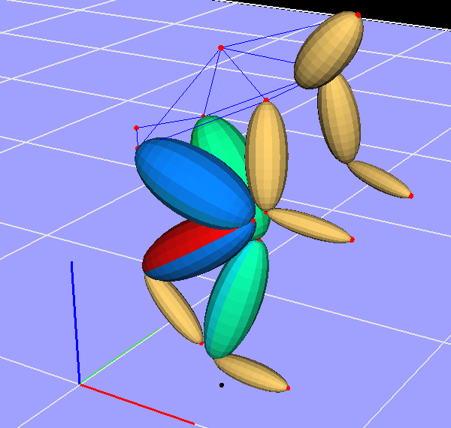
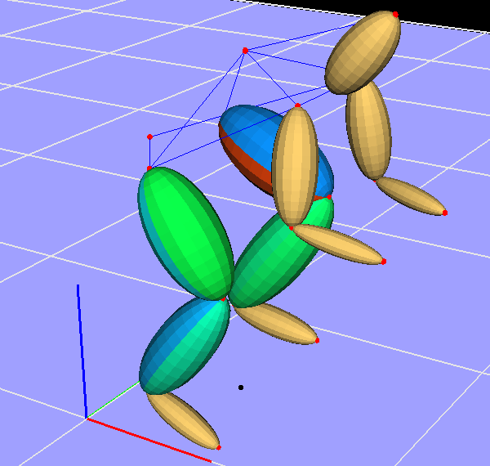
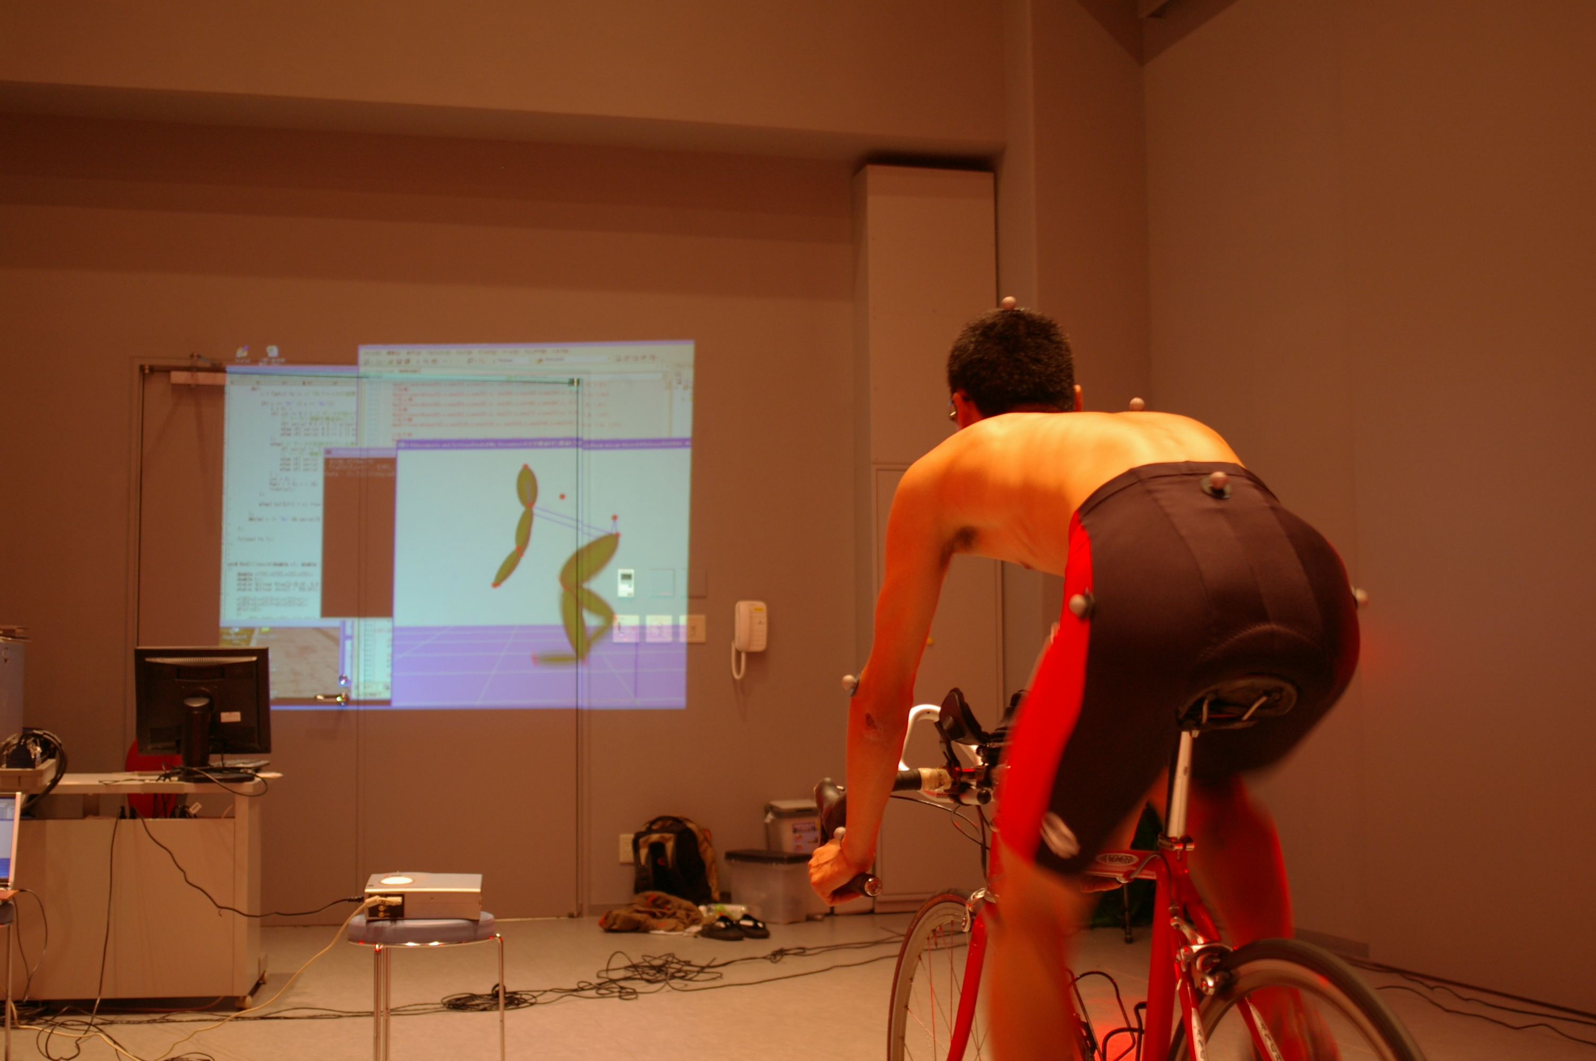
A human body model in an animation is constructed by using only the position of feature points. A body part in the model has no expression of rotation and twist of the part. Thus there is a case that the position of mapping kinesiological information onto a human body model does not fit the position of a muscle in a real motion. It is necessary to solve this problem in the future.
Fig. 13 Examples of cycling motion
Fig. 14 A cycling training scene using our visualization method.

4. CONCLUSIONS

In this paper, we proposed a visualization method for observing kinesiological information in a motion effectively. Those kinesiological information are mapped onto corresponding parts of a human body model with a variation of colors. An animation with the human body model is generated by using video images. Our proposed method allows users to understand the transition of kinesiological information in detail. Also, our method can be used for displaying real motion, adding some kinds of information. This is one of methods for augmented reality. Thus our method can be applied to virtual reality fields.
As a result, our method makes it easy to understand kinesiological information and motion visually. In a future work, we have to evaluate our method’s effect in Visual Training.

ACKNOWLEDGEMENTS

We would like to thank colleagues of the Hasegawa laboratory for their encouragement and assistance. Special thanks to Marvin Lenoar for English assistance on this project. This research was supported in part by the grant-in-aid for Private University High-Tech Research Center and grant-in-aid for Young Scientists from the Ministry of Education, Culture, Sports, Science and Technology, Japan.

5. REFERENCES

- Andreas Pommert et al, “Creating a high-resolution spatial/symbolic model of the inner organs based on the Visible Human”, Medical Image Analysis, 5(3), pp.221-228, 2001
- Luciana Porcher Nedel, Daniel Thalmann, “Anatomic modeling of deformable human bodies”, The Visual Computer 16, pp.306-321, 2000
- Asako SOGA, “Web3D Dance Composer: A Web-based Ballet Performance Simulation System” Proc. 11th International Symp. on Electronic Art, pp.16-19, 2002
- Hiroshi INABA, Tsuyoshi TAKI, Shinya MIYAZAKI, Junichi HASEGAWA, Mitsuhiro KOEDA, Hidehiro YAMAMOTO, and Kaoru KITAGAWA, “Visualization of Human Body Sensing for Supporting Sports Motion Analysis”, Journal of the Society for Art and Science, Vol. 2, No. 3, pp.94-100, Sep. 2003. (Japanese)
- Motion Analysis Corporation, URL: http://www.motionanalysis.com/
- Kenichi OGAKI, Yoshio IWAI, and Masahiko YACHIDA, “Posture Esitmation Based on Motion and Structure Models”, IEICE Trans. Inf.＆Syst. (Japanese Edition), Vol. J82-D-II No.10, pp. 1739-1749, Oct. 1999.
- Jiang Yu Zheng, Shigeru Suezaki, Yasuhiro Shiota, “Interactive Human Motion Acquisition from Video Sequences”, Proc.Computer Graphics International, pp.209-217, 2000
- Y.I. Abdel-Aziz, and H.M. Karara, “Direct linear transformation from comparator coordinates into object space coordinates in close-range photogrammetry”, Proc. Symp. Close-Range Photogrammetry, pp.1-18, 1971.

