A System for Reading Comics on Cellular Phones and Comic Image Decomposition

Masashi YAMADA (1), Rahmat BUDIARTO (2), Mamoru ENDOH (3) and Shinya MIYAZAKI (4)
(1) School of Computer and Cognitive Sciences, Chukyo University, 101 Tokodachi, Kaizu-cho, Toyota, 470-0393 Japan
E-mail: myamada@sccs.chukyo-u.ac.jp
(2) School of Computer Sciences, USM, 11800 Minden, Pulau Pinang, Malaysia, E-mail: rahmat@cs.usm.my
(3) School of Computer and Cognitive Sciences, Chukyo University, 101 Tokodachi, Kaizu-cho, Toyota, 470-0393 Japan
E-mail: endoh@sccs.chukyo-u.ac.
(4) School of Computer and Cognitive Sciences, Chukyo University, 101 Tokodachi, Kaizu-cho, Toyota, 470-0393 Japan
E-mail: miyazaki@sccs.chukyo-u.ac.

Abstract
This paper presents a system for reading comics on cellular phones. It is difficult to display high resolution images in a low resolution cellular phone environment. It is necessary for comic images to be divided into frames and the contents such as speech text to be displayed at a comfortable reading size. We have developed a scheme how to decompose comic images into constituent elements frames, speech text and drawings. We implemented a system on the internet for a cellular phone company in our country, that provides downloadable comic data and a program for reading.

Introduction
Comics are one of popular reading. People traditionally read comic books in Japan. Nowadays, there are many e-comics services available on the web, but they can only be accessed through desktop or laptop computers. It would be even more convenient if we could read comics on mobile computers such as, PDA or cellular phones. We therefore tried to develop a system for reading comics on cellular phones. The problem, which arose in the development of the system, was how to display high resolution images in a low resolution cellular phone environment.

Comics are originally printed in high quality image on B6, A5 or B5 paper, but cellular phone’s screens’ resolution is about 130x150 pixels. Therefore, it is difficult to reproduce high quality comic images on them.

We transmit comic image data from web servers to cellular phones through mobile phone links, which are a narrow bandwidth and the cost is expensive at present. Moreover, the memory capacity of cellular phones are limited. Therefore, cellular phones can’t handle heavy image data and needs to be as small as possible.

To overcome these problems, we propose a scheme how to decompose comic images into constituent elements, such as frames, speech text and drawing. We implemented a system for a company’s cellular phone users who can access the web, that provides downloadable comic data and a program for reading.

We used real comics written by a famous Japanese comic writer, Osamu Tezuka to demonstrate the system (Tezuka, 1992).

Related Work
Mobile phones are small in size, and have a relatively small memory and processing capacity. The wireless bandwidth is also rather limited compared to wire-line networks. Ojanen, et al(2000) proposed a compression method in Wireless Application Protocol environments, but it is only effective in a specific application.

There is some work about comic image processing. Yamada et al (1999) proposed a personnel recognition method. Syeda-Mahmood et al (1999) proposed a method to detect texture patterns in comic images. But, these techniques are difficult to be applied in general cases. Our approach does not need to deal with object recognition.

Kurlander et al (1996) developed Comic Chat. This system generates a comic automatically from chat data. In order to generate a comic, the system selects various character patterns prepared in advance. But, it needn’t any image processing techniques.

Chen et al (2000) explored the issues of compression methods to perform efficient data transfers from server to client. Instead of using a fixed method, they chose a combination of compression methods, that use statistical and semantic information of query results. Their techniques achieved significant performance improvements over standard compression tools like WinZip.

Overview

Comic Structure
Comics consist of pages. Each page has frames. Each frame has speech text and drawn images. This structure is represented as follows.
A comic is a set of pages $P$. A page $p∈P$ is a set of frames $F$. The elements of$F$ have an order and can be made into a sequence:
$f_{1}< f_{2} <⋯ < f_{n}$,
where $f_{i}∈F$. A frame $f∈F$has some groups of speech text. A group of speech text usually corresponds to a speech bubble in the frame. The elements of speech text bubbles $S$ have an order and can be made into a sequence:
$$s_{1}< s_{2} <⋯ < s_{m}$$
where $s_{i}∈S$. A frame $f∈F$ has a drawn image where speech text was removed from the original frame image. Consequently, a frame is represented as follow:
$$( d, S),$$
where $d$is a drawn image.

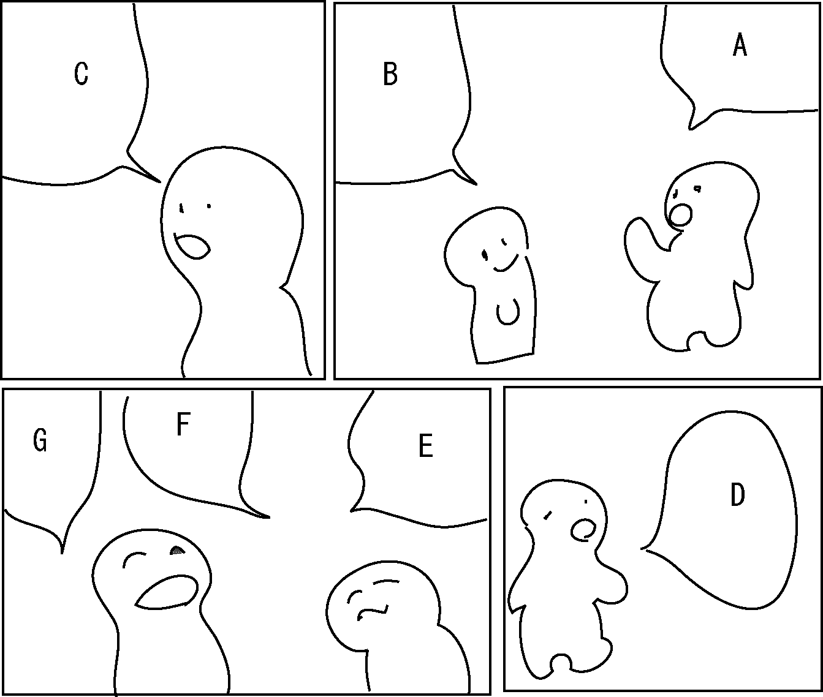
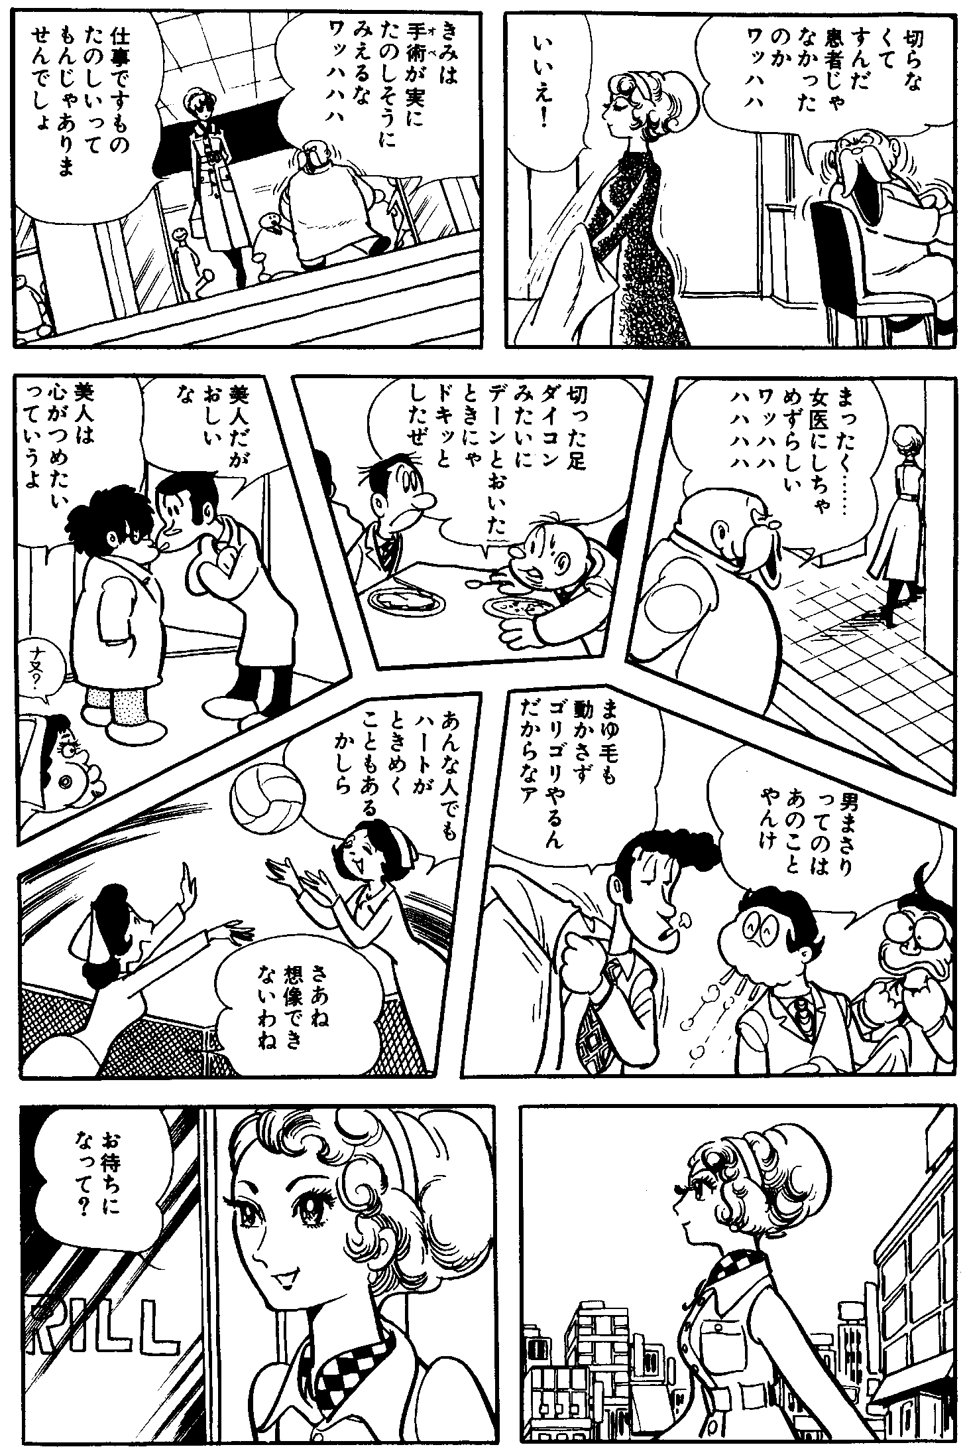
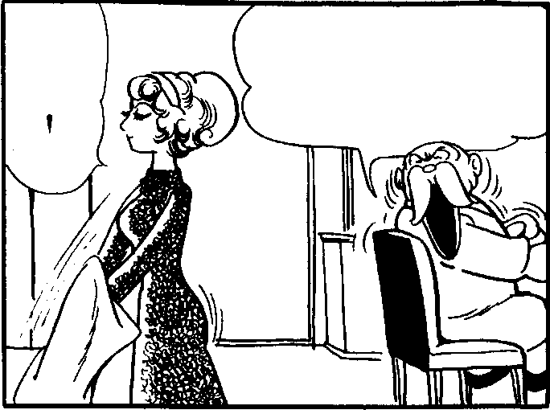
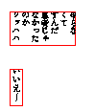
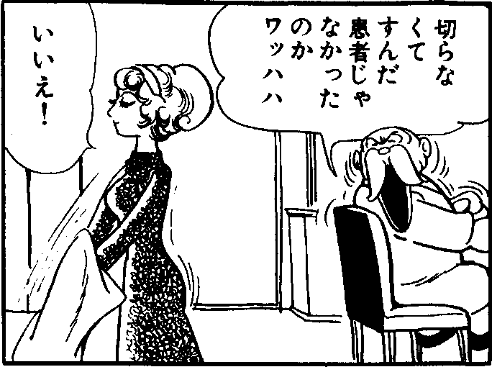
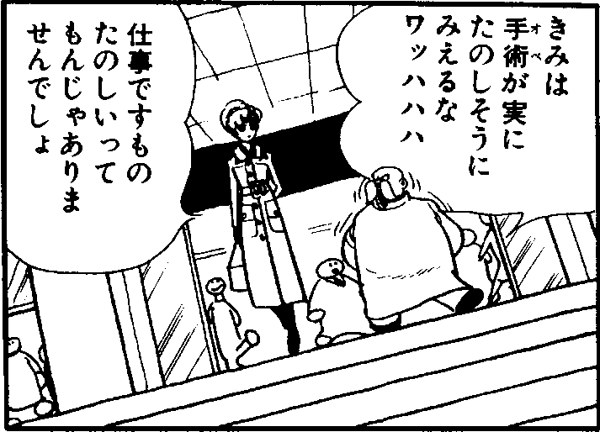
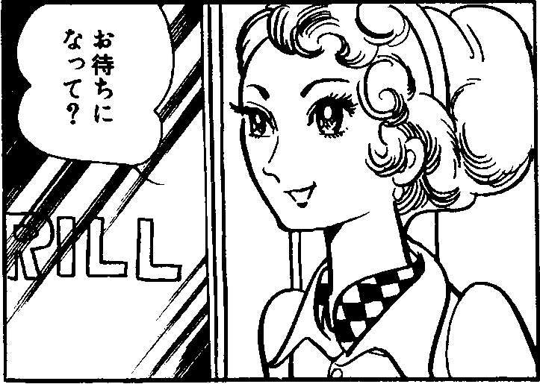
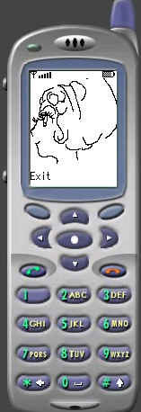
Example: Figure 1 illustrates a page of a comic. This page has 4 frames $f_{1}< f_{2} <f_{3} < f_{4}$ in this order. Japanese comics are presented in this order from right to left. (This order is Japanese comic style.) Each frame has/have groups of speech text. For example, frame $f_{4}$ has three groups of speech text, E, F, and G in this order. Also, $f_{4}$ is represented as $( d_{4}, \left\{ E, F, G \right\} )$, where $d_{4}$= 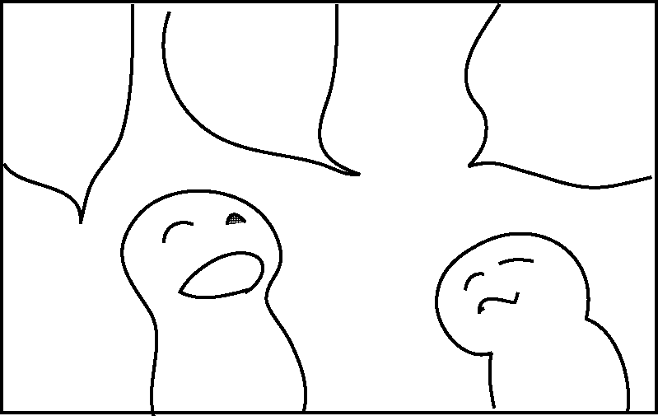 .
Figure 1 A comic page
A
B
C
D
E
F
G
Figure 2 System overview for reading comics on cellular phones
Generating Comic data and providing download data
Drawn image data + Speech text data + A customized java program
speech text sequence
drawn image
…
frame sequence
Frame detection and sorting
Speech text extraction
OCR
Down load
from the Web
An image of comic page
Cellular phone
Compression

Outline of the Reading Comic System
In this section, a system for reading comics on cellular phones is outlined. The scheme of the system is shown in Figure 2. The input is an image of comic page. This image is obtained from a scanner as a binary image with about 400dpi resolution, which is enough. First, the system detects the frames and establishes a sequence of them by analyzing their layout. Next, the system extracts speech text from each frame image, then speech text is made into some groups, and establishes a sequence by analyzing their layout. Speech text is recognized by using OCR. The remaining drawn image is compressed and formatted for cellular phone display.
We developed a customized java program that is uploaded with frame data to the server, for Web use. It acts as an engine and enables cellular phones to reproduce frames from the data.

Frame Sorting
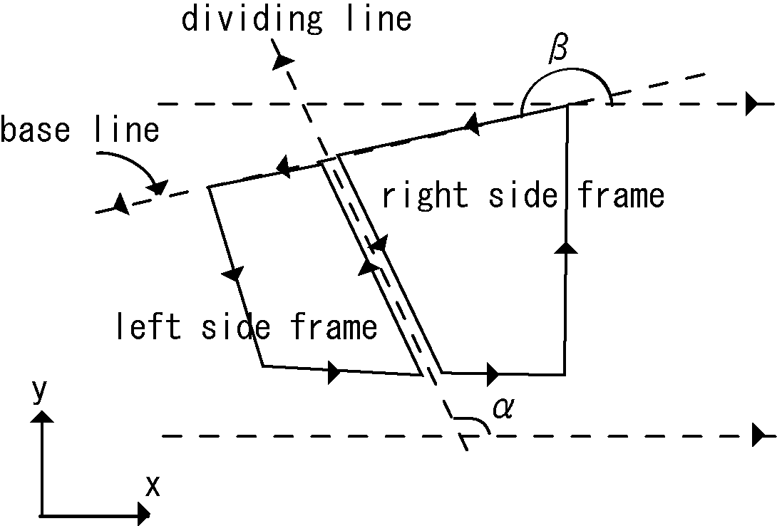
In this section, a frame sorting method is described. There are many layout analysis systems, which are limited. Their target is specific domain documents such as office forms, newspapers and so on. Unfortunately, there is no layout analysis system for comic frames. The shapes of comic frames are not just rectangular but are polygonal in general. A new layout analysis method had to be formed to make frames into a sequence. We assume the followings:
Figure 3 The base line and the divided line

1. Frames are convex polygons.
2. A comic page sequence starts from right to left.

Reference 1 is a restriction to our system. Reference 2 is supposed for easy explanation in the following sections.

Frame Sorting Rules
First, we define three rules; R1, R2, and R3, for sorting two neighboring frames (see Figure 3). We created a line between the two neighboring frames and called it the dividing line. Let the direction of the dividing line have a positive y value or be the same of x axis (i.e. the direction vector $(x,y)$satisfies $y>0$ or $(1,0)$ ). An example of the dividing line is shown in Figure 3. The dividing line is parallel to the neighboring border lines of the two neighboring frames. The frame on the right side of the dividing line is called the right side frame. The other is called the left side frame. The first rule uses an angle, $α$, to sort the right and left side frames. $α$ is the angle formed where the x axis and the dividing line cross each other. The rule is defined as follow:

(R1) ${\text{90}}^{∘} ≤α <{\text{180}}^{∘} ⇒ \text{rf} < \text{lf}\text{.}$
where $\text{rf}$ and $\text{lf}$ corresponds to right and left side frames respectively.

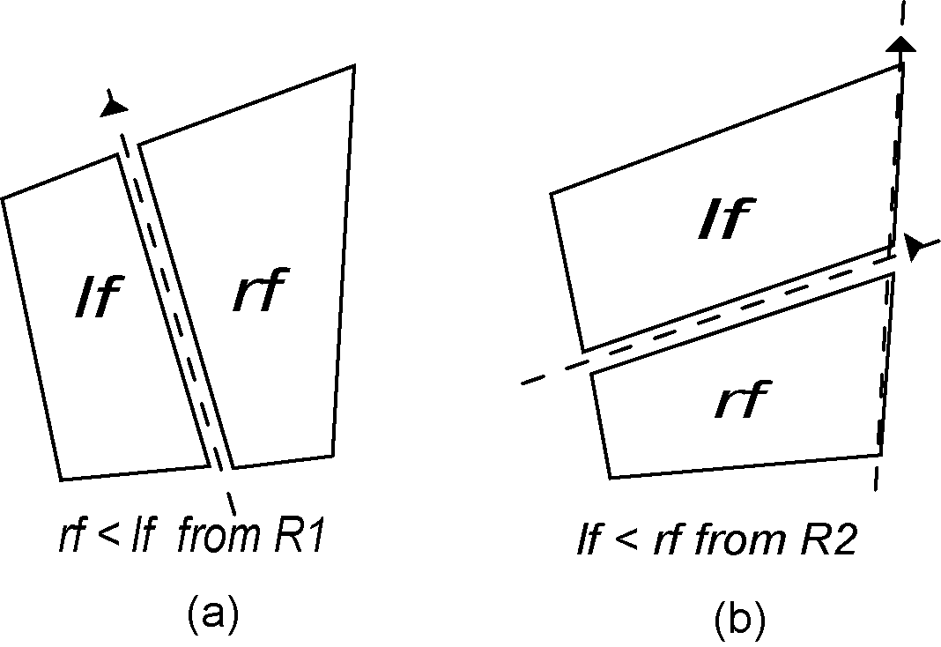
Example: Figure 4(a) shows an example sorting two neighboring frames. From rule R1, $\text{rf} < \text{lf}$is obtained.
Figure 4 Examples of sorting two neighboring frames

R2 and R3 are rules for only two neighboring frames that satisfy $0^{∘} ≤α < {\text{90}}^{∘}$ and have a common line border (see Figure 3). This common line is called a base line. Border lines of frames are given a direction counterclockwise. The base line is given the same direction as the border lines. R2 and R3 use two angles, $α$and $β$, to get the order of the right and left side frames. $β$ is the angle formed where x axis and the base line cross each other. R2 and R3 are defined as follows:

(R2) $0^{∘} ≤α < {\text{90}}^{∘} ∧ α ≤ β ≤ {\text{135}}^{∘}⇒ \text{lf} < \text{rf}\text{.}$
(R3) $0^{∘} ≤α < {\text{90}}^{∘} ∧ {\text{135}}^{∘} < β < α+{\text{180}}^{∘}⇒ \text{rf} < \text{lf}\text{.}$

Example: Figure 4(b) illustrates an example of sorting two neighboring frames. From rule R2, $\text{lf} < \text{rf}$is obtained.

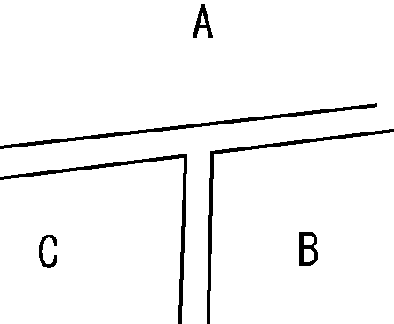
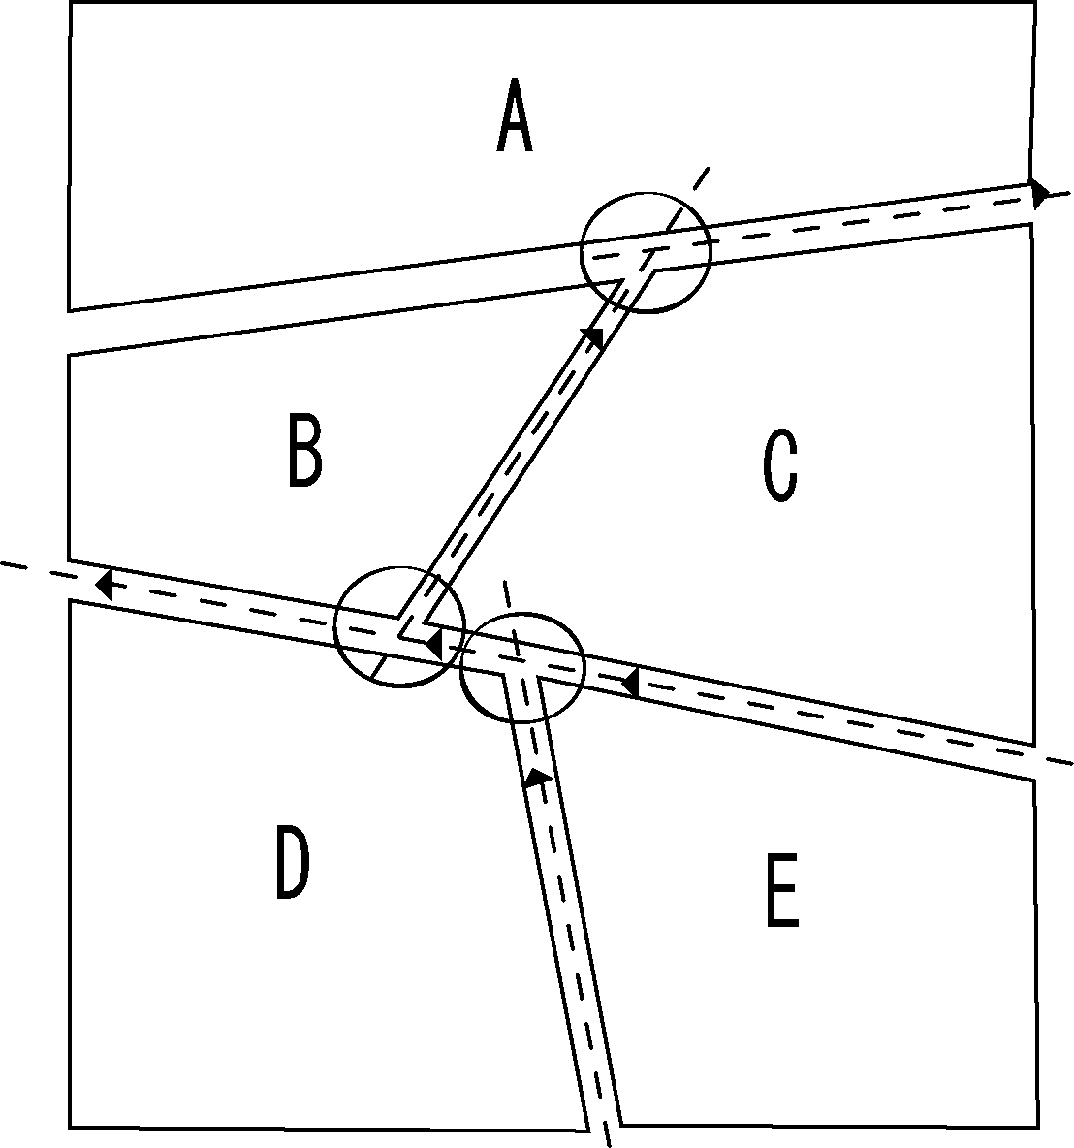
Next, we defined a constraint rule for sorting three frames that form a ‘T’ pattern shown in Figure 5. Frames B and C have common base lines. Frame A is neighboring both frames B and C. We call this case ‘T- type neighboring’ and represent it as $t$(A, B, C) or $t$(A, C, B). The constraint rule is defined as follow:
Figure 5 T-type neighboring, t(A,B,C)
Figure 6 An example T-type neighboring and dividing lines

(R4) $t( f_{1}, f_{2}, f_{3} ) ⇒ (f_{1} < f_{2} ∧ f_{1} < f_{3} ) ∨ (f_{1} >f_{2} ∧ f_{1} > f_{3} )$

Example: Figure 6 shows an example of a comic page, which has five frames. We obtained the order of frames as follows: From rule R1, C < E, C < D, B < D, E < D were obtained. From rule R2, A < C was obtained. From rule R3, C < B was obtained. There are three ‘T-type neighboring‘ cases which are indicated by circles. From the constraint rule R4, we have (A < C A <B) or (A > C A > B) for t(A,C,B). A < C has already held, then A < B.

A Frame Sequence Search
Next, a depth first search is used. This search finds a unique sequence of frames that satisfies frame sorting rules R1, R2, R3 and R4.
We explain in detail the search process in the Appendix and use the following example to illustrate resulted frame sequences.
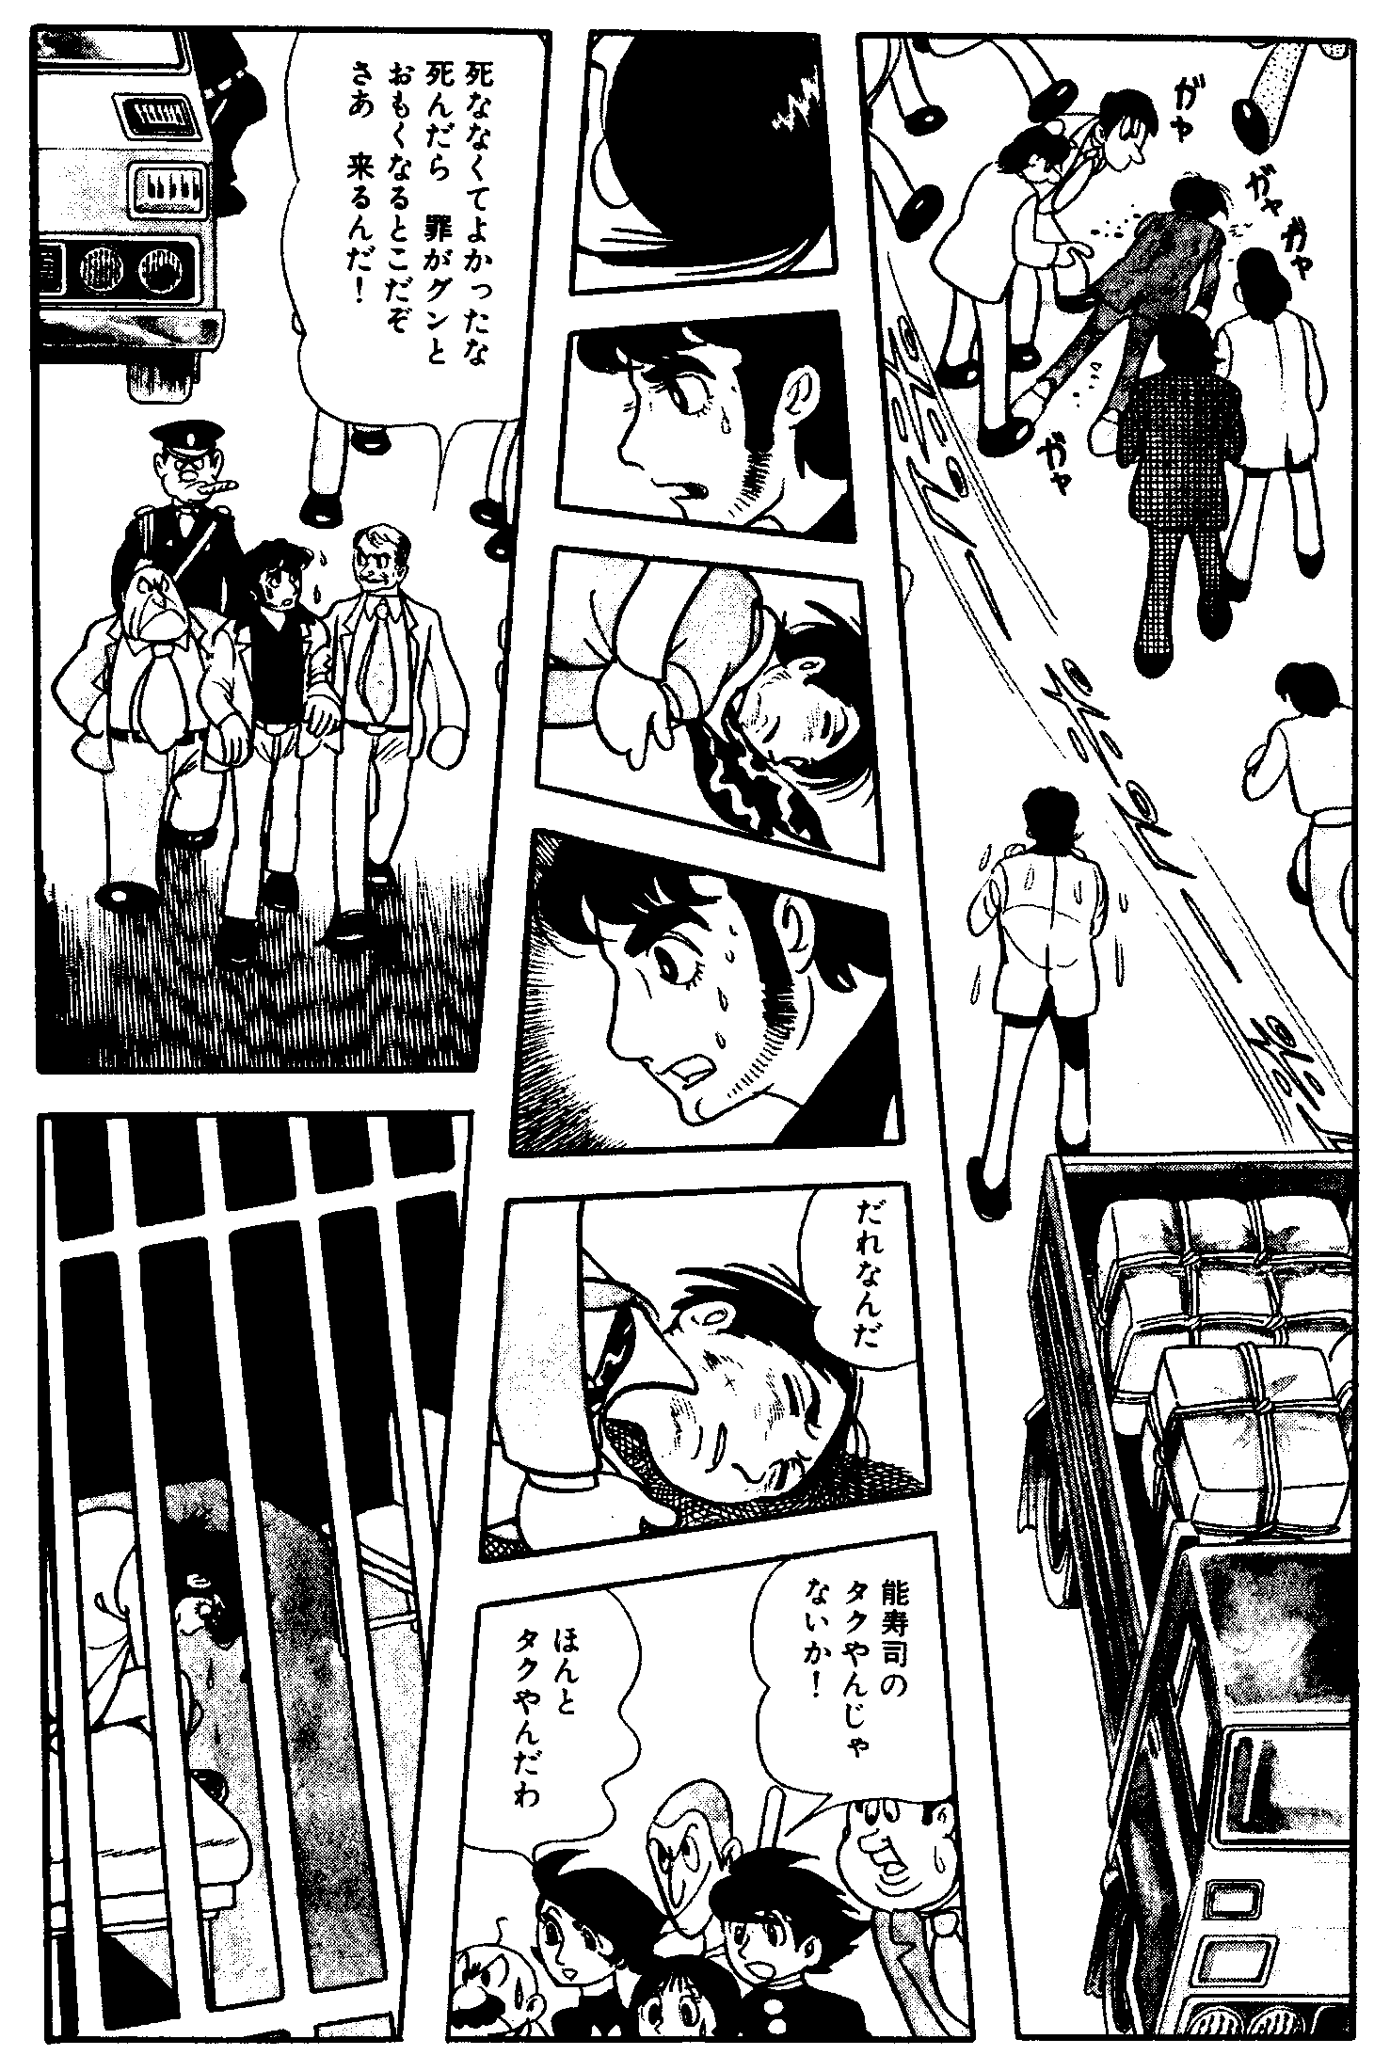
Example: Figure 7 shows two comic pages. The proposed frame sequence search gives the sequence $B<A<E<D<C<G<F<I<H$ from the image in Figure 7(a).
(a)
(b)
Figure 7 Two comic pages
Also, the sequence$F<B<C<D<E<H<I<A<G$is obtained from the image in Figure 7(b).

Speech Text Sorting
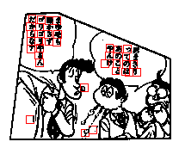
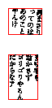
In this section, we propose a speech text sorting method. Before the sorting process, we detect speech text in frames by the following process. First, all letters are detected by scanning a frame (see Figure 8(a)). Then, the detected letters are gathered together on the basis of distance between letters (see Figure 8(b)).
(a)
(b)
Figure 8 Detected letters and groups of speech text
If a frame has more than two speech text bubbles, they have an order. Here, a sorting rule is defined for two speech text bubbles. Rectangles enclosing speech text are defined in each speech bubbles. Then the top and right side edge positions of the rectangles become an index used for sorting (see Figure 9). $s$ and $s^{'}$ are speech text bubbles, $P(s)$and $P(s^{'})$ denote the top and right side position of $s$ and $s^{'}$ respectively. $\text{dist}(p)$ denotes the distance between position $p$ and the top and right side edge of the frame. The sorting rule for $s$ and $s^{'}$ is defined as follows:

(R5) if $\vec{V}=P(s^{'})−P(s)$ is between ${\vec{v}}_{1}=(1,1)$ and ${\vec{v}}_{2}=(−1,1)$, then $s^{'}<s$, otherwise if $\text{dist}(P(s^{'}))<\text{dist}(P(s))$, then $s^{'}<s$, otherwise $s<s^{'}$.

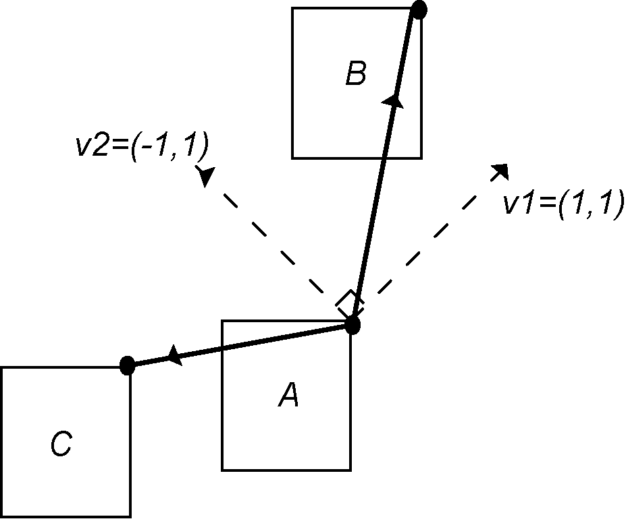
Example: Figure 9 shows an example. Speech text bubbles A and B have an order B<A, whereas A and C have an order A<C.
Figure 9 Speech text sorting examples (B < A, A < C)

A sequence of speech text bubbles can be found by rule R5.

Example: Figure 8(a) has two speech text bubbles. The sequence of these bubbles are shown in Figure 8(b).

Data

Drawn Image Data

Drawn images are obtained from frame images by removing speech text. These drawn images are formatted to be displayed on cellular phone’s screen. First, we reduce resolution to fit cellular phone’s screen. During this process, the drawn images are converted from the binary image to the gray-scale image by bi-cubic convolution. Each pixel of the obtained gray-scale image has a density value represented by 8bit. Then we compress the obtained gray-scale image.
In general, there are many white spaces in drawn images because they are drawn by pen on white planes. On the other hand, the stroke of a pen is smooth. In low resolution environments, aliasing appears if strokes are represented by only 1 bit color. Therefore, the density value in the gray-scale image is important information. From these reasons, we employ the following compression method:
Drawn images are divided into some blocks. A block is called white block (1) if all pixels in the block are white (density value is 255). Otherwise, the block is called gray-scale block (0). Pixels in gray-scale block are represented by gray-scale indexes, w, g1, g2, …, gn and b (see Figure 10).
The above compression method is efficient in the case in which there are many white spaces and little texture patterns in drawn images.

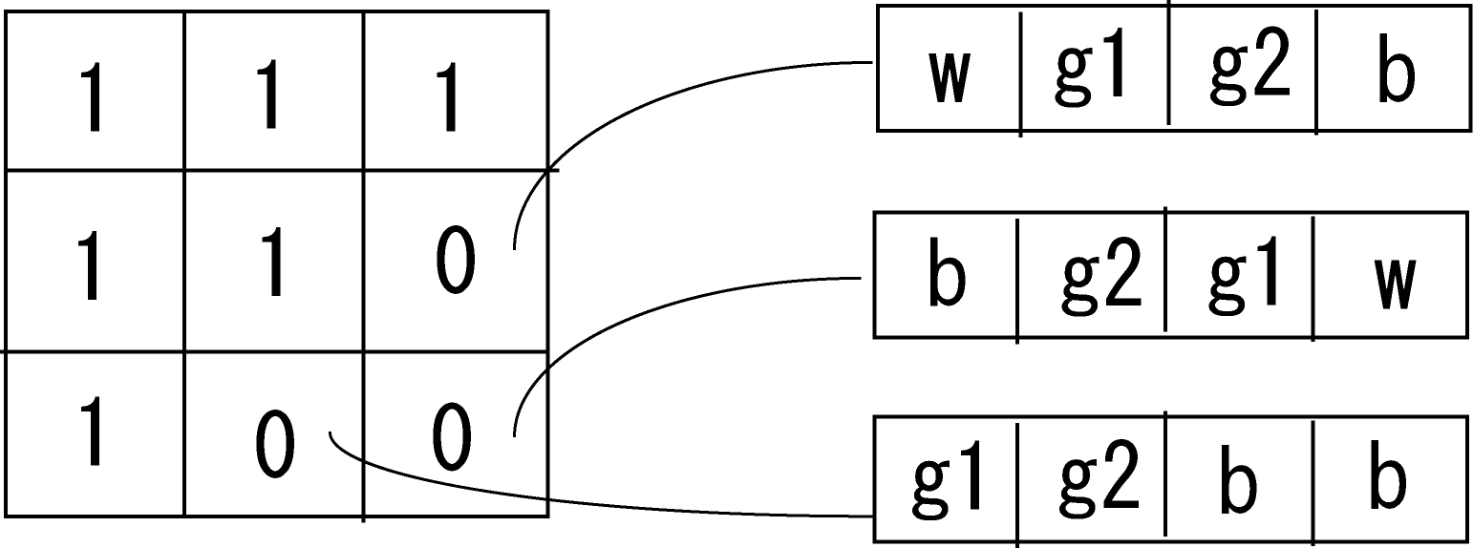
Speech Text Data
Figure 10 Block data (white block(1) and gray-scale block(0) ) and pixel data in gray-scale block (0)
Speech text of frames is recorded in a text file (see Figure 11). In this file, each row corresponds to a speech text bubble. Furthermore, the position (coordinates) of speech text bubbles is put at the head of each row.
( 10,10) まったく しょうの…
(110,20) おかげで かれと…
Figure 11 An example of speech text data file

Implementation

Cellular Phone Program
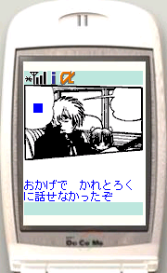
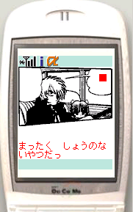
Figure 12 Examples of reproduced comic on a cellular phone
We implemented a cellular phone program in Java. We call it, comic engine. This engine reproduce drawn images and speech text for cellular phone screens from downloaded data. Figure 12 shows two screen shots. In order to make speech text easily read, we use cellular phone fonts to represent them. Furthermore, to indicate the corresponding bubble; we put a mark (a small rectangle with the same color as the speech text) inside the bubble. Users can switch between speech text and frame areas by pressing a button.

Providing Comic Data on the Web
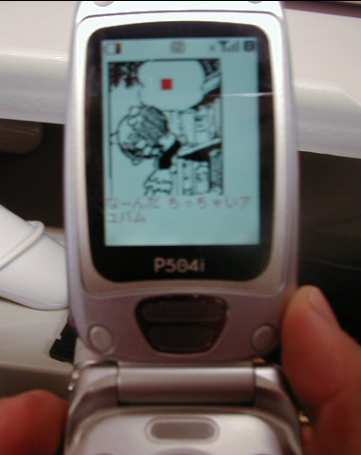
In our experiments (see Figure 13) we used a real comic story which consists of 23 pages. We scanned all the pages and translated them into compressed drawn image data and speech data. Then we uploaded them to a web server. Through cellular phones, users can access the website and download the comic engine and comic data. Selected buttons are used to navigate the sequence of the comic.
Figure 13 A snapshot of the experiments




Once users download the engine, it is not necessary to download the engine again, since the engine can be used regardless of comic contents. In the current system, users have to download the engine for each page. We can choose the way of providing the engine. The data can be downloaded separately. We want to investigate and determine which way is best from the viewpoint of user interface, encipher and so on.
12Kbyte
15Kbyte
3Kbyte
2Kbyte
Figure 14 Pre-compressed images (left) and reproduced images by our engine (right)

Evaluation of Data Size
The cellular phone employed in our experiments limits the application size to less than 30Kbyte. Our application (the engine and the comic data of one page) size was about 19Kbyte for each of the 23 pages. Here, we evaluate our compression method for the drawn images. Figure 14 shows two examples in the upper row and in the lower row respectively. The left side image in each row is pre-compressed (gray-scale image reduce) to fit cellular phone screens. The right side image in each row is the reproduced image in a cellular phone. The size of the pre-compressed image is 12Kbyte and 15Kbyte respectively, whereas the size of the compressed data is 2Kbyte and 3Kbyte respectively. These sizes are smaller than those of GIF compression, 5Kbyte and 11Kbyte. In this experiment, pixels in gray-scale blocks are represented by 2bit gray-scale indexes (w, g1, g2, b). More parameter tuning is necessary to get better results.

Conclusion
We implemented a system for reading comics on cellular phones (and other mobile computers). We proposed a decomposition method to overcome two main problems in the implementation of digital mobile comics: screen dimension and data size. In addition, we also developed a comic engine for reproducing comics on mobile computer screens. Through various experiments, the system and the comic engine exhibited good performance.
In this paper, we started from the original paper version of comics, whereas the proposed methods can be applied to electronic comics if they are rasterized. On the other hand, we consider the vectorized version in order to deal with generic electronic comics.
We are sure that our system will become a new application service in mobile services in the future.

Acknowledgements
We wish to thank Tezuka Production Co., Ltd. for their willing consent about the use and reproduction of Tezuka’s works.

References
Tezuka, O. (1993), Black Jack, 1(1), Akita Shoten
Ojanen, E. and Veijalainen, J. (2000), Compressibility of WML and WMLScript byte code: initial results [Wireless Mark-up Language], Proc. of 10th International Workshop on Research Issues in Data Engineering, pp. 55-62.
Yamada, T. and Watanabe, T. (1999), Identification of Person Objects in Four-Scenes Comics of Japanese Newspapers, Proc. of International Workshop on Graphics Recognition, pp. 152-159.
Kurlander, D., Skelly, T. and Salesin, D. (1996), Comic Chat, Computer Graphics Proceedings, SIGGRAPH, pp. 225-236.
Syeda-Mahmood, T.F. (1999), Detecting Perceptually Salient Texture Regions in Images, Computer Vision and Image Understanding, 76, pp. 93-108.
Chen, D., Seshadri, P. (2000), An Algebraic Compression Framework for Query Results, Proc. of International Conference on Data Engineering, pp.177-188.

Appendix
A Frame Sequence Search
We use a depth first search to form frames into a unique sequence. The search starts at a frame and traces its neighboring frame recursively. If a frame $f_{c}$ has plural neighbors, the neighbors are given a priority order. The neighbors can be corresponded to each border lines of $f_{c}$. On the basis of their direction, the border lines are prioritized counterclockwise from${\text{225}}^{∘}$. The corresponded neighbor frame has the same order of priority. Let $N$ be a set of frames that are neighbors of $f_{c}$ and not yet included in the current sequence. If$f$$∈N$ has the highest priority in $N$, let $f$ be denoted by $\text{hn}(N,f_{c})$. The search also uses a minimum distance between a frame and an edge of the top and right side of the page. Let $U$ be a set of frames that have not yet included in the current sequence. If$f∈U$ has the minimal distance among $U$, let $f$ be denoted by $\text{md}(U)$. If there is no frame neighboring a current frame, the search continues from$\text{md}(U)$ . The search procedure always checks whether the sequence satisfies the order of two neighboring frames, where the order is obtained from rules R1, R2, R3 and R4. The search is complete if all frames have been included in the sequence.
A Frame Sequence Search (FSS) is shown below. We can get a frame sequence, $L$ , by calling $\text{FSS}(F−\left\{f\right\},[f],f)$, where $F$is a set of all frames in a page and $f$ is $\text{md}(F)$. The function$\text{satisfy}(L)$ returns true if $L$ satisfies the order obtained from the rules.

procedure $\text{FSS}(U,L,f_{c})$:
$U$: a given set of frames
$L$ : a list of frames ( frame sequence ).
$f_{c}$: a given frame.
begin
if ( $U=φ$) return true;
else{
$N$: a set of frames neighboring $f_{c}$.
$N=N∩U$;
while($N≠φ$){
$f_{n}$$=\text{hn}(N,f_{c})$;
$N=N−\left\{f_{c}\right\}$;
if ( $\text{satisfy}([L|f_{n}])$ and $\text{FSS}(U−\left\{f_{n}\right\},[L|f_{n}],f_{n})$ )
return true; /* C1 */
}
$f_{n}$$=\text{md}(U)$; /* C2 */
if ( $\text{satisfy}([L|f_{n}])$ and $\text{FSS}(U−\left\{f_{n}\right\},[L|f_{n}],f_{n})$ )
return true;
else
return false;
}
end

Comment lines
C1: Since there exists a frame sequence,$f_{c}< f_{n} <⋯$, satisfying the order obtained from the rules, the search finishes.
C2: The search checks whether there exists a frame sequence such that $f_{c}< \text{md}(U) <⋯$.

