Cooperative elastic object manipulation
performed by virtual joystick operation

Shigeki SUZUKI*, Mamoru ENDO**, Masashi YAMADA**, Shinya MIYAZAKI**,
Junichi HASEGAWA***, Takami YASUDA**** and Shigeki YOKOI****
* Graduate School of Computer and Cognitive Sciences, Chukyo University
** School of Computer and Cognitive Sciences, Chukyo University
***School of Life System Science and Technology, Chukyo University
101 Tokodachi, Kaizu-cho, Toyota-city 470-0393, Japan
****Graduate School of Information Science, Nagoya University
Furo-cho, Chikusa-ku, Nagoya-city 464-8601, Japan

Abstract. This paper presents a virtual manipulation environment dealing with elastic objects. An original fast computation elastic model ‘the gradational resolution model’ is introduced for real-time interaction, in which the number of elastic elements are efficiently reduced for acceleration. Joystick force feedback is used for sensible interaction. Two kinds of collision algorithms are examined by joystick operation. Finally, virtual manipulation can be implemented, such as pushing elastic objects against the wall with a joystick, pinching and lifting up elastic objects with a pair of joysticks.

1. Introduction

Physically-based modeling is an effective way to generate natural motion of deformable objects by defining a comparatively simple model that represents the local properties of objects [1]. In the field of computer animation, it has been developed for the purpose of generating real motion of deformation as an animation. Thanks to great advances in computation performance, the possibilities are increasing more and more to extend real-time applications such as surgical simulation [2]-[4]. To develop a virtual manipulation environment, it is also important to design how to realize interaction with input devices. It is necessary to develop interaction algorithm considering what kind of IO functions are available in the input device.
We have been developing a fast computation elastic model [5]. An original elasticity element model performs consistent restoration, and is applicable to any shape of polyhedron elements. To save motion computation time, variable sizes of elastic elements are laid gradationally in constructing elastic objects. Small elements are laid on the object’s surface to keep high resolution. On the other hand, large elements are laid in the center of the object to save computation time, in which elements are invisible and transformation degrees are comparatively smaller than those on the object’s surface. It is used as a platform in this study.
The collision process between elastic objects and input devices have an important role in developing the manipulation. A physically-based approach for elastic behavior and collision processing takes much computation time. Parallel processing will be a solution in the future. Models have to be limited at present. Collision processing is limited between elastic object’s surface vertices and geometric surface of obstructions. Based on that, two kinds of collision algorithms are examined by force-feedback joystick devices. Finally, virtual manipulation is constructed, such as pushing elastic objects against the wall with a joystick, pinching and lifting up elastic objects with a pair of joysticks.
2. Elastic Object Model

In this section, the volumetric elasticity element model and the gradational element resolution models are explained as fundamental models used for virtual manipulation.

2.1. Volumetric elasticity elements

We have developed an original elastic element model. Either mass-and-spring model or simplex element in FEM (Finite Element Method) is generally used as an elastic element model. Our model solves instabilities and improprieties in mass-and-spring model when elastic elements are strongly deformed. Our model’s concept is simple and we have developed a fast computation method to solve it numerically. It permits any number of vertices in the element. It is an advantage to be free from subdividing elements into simplex elements or truss structured springs, which is necessary in other models. Free vertex layout is a necessity for constructing our gradational resolution model.

2.2. Definition of elastic force
Figure 1.Vertex displacements in a volumetric elasticity element. Solid lines show the original reference shape, broken lines show the rotated reference shape, and bold lines show the deformed shape.
R_{i}
Ro_{i}
R_{i}
r_{i}

Followings are definition of elastic force in our element model. Restoration force is proportional to the vertex displacements in the element from the reference position, that gives its reference shape, the goal of element restoration (Figure 1). The reference shape’s location is decided in each element as is; both the resultant internal force and the moment of force of the internal stresses are equal to zero vectors.

$\sum_{i}{r_{i}×k (R_{i}−r_{i})}=k\sum_{i}{r_{i}×R_{i}}=\vec{0}$ (1)

Here, vector R_{i} and r_{i} are relative positions of vertex i in the reference shape and the deformed shape with respect to the center of gravity, respectively. Force is proportional to displacements with proportionality constant k.
In the implementation, the initial values of { R_{i} } are registered as { Ro_{i} }, and { R_{i} } is defined as a result of the rotation of { Ro_{i} } around the center of gravity.
Our model becomes relatively similar to FEM model in elastic force definition when element shapes are of a regular triangle shape or regular tetrahedron shape. After elastic force is decided, velocity and position for each vertex is renewed by difference equations of motion that are established locally in each vertex.

2.3. Policy for element reduction

One simple method of element reduction is by replacing a few elements with one large element. If the element reduction procedure is performed and applied, only when element deformations are comparatively small, this could be an effective element reduction. More computation time is needed to search such elements. Also, it is difficult to predict deformation tendencies beforehand. However, deformation is large around contact points with rigid objects. External force from rigid objects is far larger than internal force in elastic objects, and works directly on the surface of elastic objects. Connection between elements also constrains elements’ deformation. This works less on the surface where fewer neighboring elements are joined.
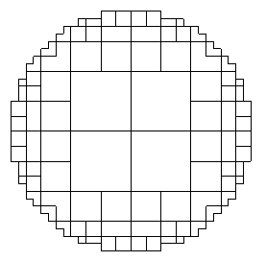
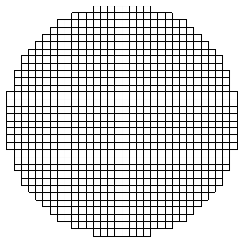
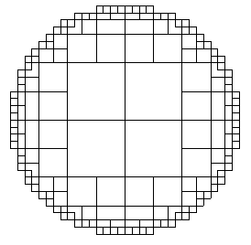
Based on the above considerations, we proposed a model whose element size can be gradationally increased from the surface to the center (Figure 2). The minimum element’s shape is square and has one vertex on each corner. The other elements’ shapes are more complex. It effectively saves computation time and maintains the original voxel resolution on the surface.
Figure 2.Image illustrations of a gradational element resolution model. (b) is a magnified illustration of a corner of a cubic object (a).
(a)
(b)
(a) original (b) low compression (c) high compression

Figure 3. Element and vertex layouts of gradational resolution models for a round shape object.
Computation’s size is roughly proportional to the number of elements. A n by n by n cubic voxel object has n ³ elements. They are reduced into 8 n ² by the gradational resolution model, which has the same resolution on the surface. Compression rate is about 8 / n. Compression becomes more effective in large numbers of n. In two dimensional cases in Figure 3, a round object, which can fit mostly into a 32x32 square, has 812 square elements before reduction (Figure 3 (a)). After reduction, it is constructed by 172 or 92 elements, respectively, in the two kinds of element layout (Figure 3 (b) and (c) ). All models have the same resolution on the surface.

3. Collision Processing

In developing the manipulation, collision process between elastic objects and input devices has an important role. In this section, two kinds of collision algorithms are examined with force-feedback joystick devices. Models have to be limited ones for real-time processing. Collision processing is limited between each of the elastic object’s vertices and the rigid surface, that can be described in a geometrical formula.

3.1 Virtual spring method

In reference [6], a collision process is realized by placing virtual springs between rigid objects (Figure 4). This creates a collision force between objects when they overlap each other. If the spring is assumed to have a linear property, the magnitude of collision force is proportional to the depth of overlap, that is the depth of penetration of the vertex inside the rigid surface. This method is well-suited for physically-based dynamic simulation, which is performed by integrating force defined at each discrete time. However, overlaps between objects are impossible in a real collision phenomenon. To realize that in this method, rigid surface has to have a significantly large spring constant. It is unsuitable in the approximation solution for physically-base simulation.
Figure 4.Collision force in the virtual spring method. The magnitude of collision force is proportionally increased according to the depth of vertex penetration.
Figure 5.Pre-position and post-position of elastic collision in the constraint method.

3.2 Constraint method

To avoid the problem of overlapping in the virtual spring model, we have employed a constraint-based method. It supposes that the vertex on the elastic object surface makes the elastic collision against the rigid wall (Figure 5). Because, the collision phenomenon is performed in a short time compared to the period of elastic object’s oscillation. Kinetic energy is conserved in both methods as a whole. It guarantees consistent results globally.

3.3 Feedback force

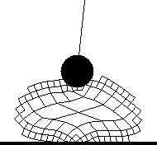
Feedback force can be obtained by integrating collision force applied to elastic object’s vertices in both methods. Although, the virtual spring method has a disadvantage of object penetration (Figure 6), it is base spring elasticity is more suitable for force-feedback than the constraint method. Collision force in the constraint method forms an impulse-shape (Figure 7). It generates a vibrating force. Also, elastic body constructed by discrete vertices generates rough force. In the virtual spring method, consistent results are made in both suppression of penetration and stability of feedback force, when spring constant of virtual springs is ten times that of elastic objects. For stabilizing feedback force, feedback force is also smoothed along time by examining past ones.
Figure 6.Penetration between the elastic object and the manipulator in the virtual spring model. The thin line on the manipulator indicates the direction of feedback force.
Figure 7.Feedback force generated by two kinds of collision algorithms.

4. Virtual Manipulation with Joysticks

4.1 Overview

The SensAble Technologies PHANTOM is a pioneer in desktop force-feedback devices. Although, it is still expensive, it has widely become a standard for constructing force-feedback manipulation among researchers in the field of virtual reality. On the other hand, joystick devices developed for PC games also have a function of force-feedback such as Microsoft Side Winder Force Feedback 2 used in subsection 4.2. Although, it has no function to point three-dimensional positions directly, the function of slider can be used for control of two-dimensional movements. When we manipulate objects with a tool in the real world, it often performed by gripping a stick-shaped handle, for example, rackets in sports or a surgical knife. Joysticks provide a natural interface of grasping a handle and easily express a force-feedback feeling through the handle. Two-dimensional controls are sometimes more desirable for the case in which preciseness and stability are demanded than completely constraint-free three-dimensional controls. Introducing consumer products also contributes revitalization of VR researches with force-feedback.

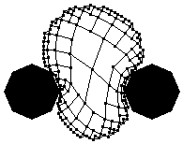
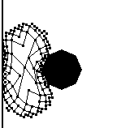
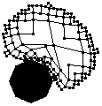
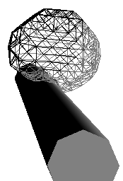
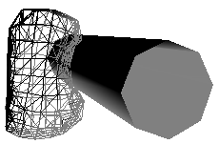
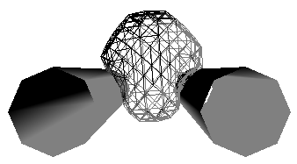
4.2 Implementation
(a) pushing an object (b) pinching with a wall (c) pinching with two joysticks

Figure 8. Examples of virtual manipulation with joysticks.

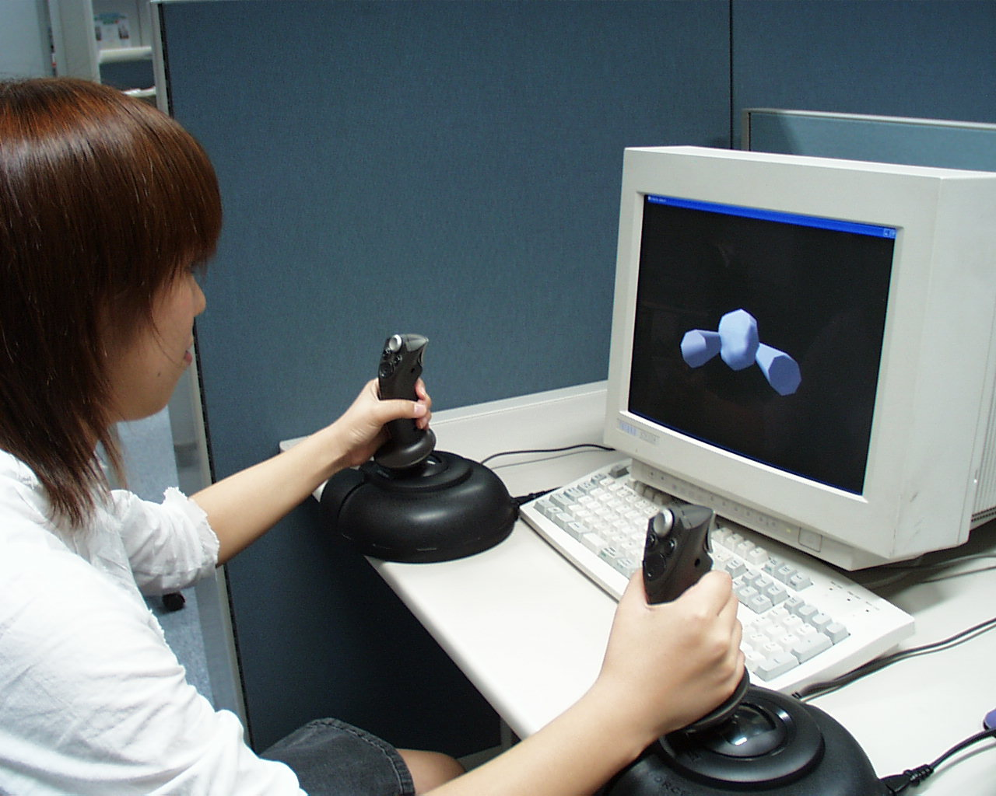
Two- and three-dimensional manipulation environments are implemented (Figure 8). A round and spherical elastic object has a gradational element layout. A rigid circular or cylindrical manipulator is controlled by a joystick. According to the direction and inclination angle of joysticks, two-dimensional movement of manipulator is controlled. In Figure X (c), two manipulators are cooperatively controlled by two joysticks to pinch an object (Figure 9).
Figure 9. Cooperative manipulation with two joysticks.
Collision force is applied to element vertices to push them outside the manipulator when the vertices are inside the manipulator. Collisions between elastic elements are not detected at this point.
Direct X9 SDK, that is freely distributed by Microsoft Corporation, is used on Microsoft Visual C++.Net for the development. Program codes are downloadable from our web site [7].

Acknowledgments

We would like to thank Professor Teruo Fukumura of Chukyo University for his encouragement and assistance. Special thanks to Marvin Lenoar, a great English teacher and for English assistance on this project. This research was supported in part by the grant-in-aid for Private University High-Tech Research Center and grant-in-aid for Young Scientists from the Ministry of Education, Culture, Sports, Science and Technology, Japan.

References

[1] D. Terzopoulos, J. Platt, A. Barr, K. Fleisher, Elastically Deformable Models, Computer Graphics, 21(4), pp.205-214, 1987.
[2] S. Cotin, H. Delingette, N. Ayache, A Hybrid Elastic Model for Real-time Cutting, Deformations, and Force Feedback for Surgery Training and Simulation, The Visual Computer 16(7), pp.437-452, 2000.
[3] D. Bielser, M. H. Gross, Interactive Simulation of Surgical Cuts, Pacific Graphics 2000, pp.116-125, 2000.
[4] H. Nienhuys, A. Stappen, A Surgery Simulation Supporting Cuts and Finite Element Deformation, MICCAI 2001, pp.145-152, 2001.
[5] S. Miyazaki, J. Hasegawa, T. Yasuda, S. Yokoi, Acceleration of Elastic Model's Motion Computation Based on Elastic Element Reduction, Proc. CG International 2002, pp.239-246, 2002.
[6] A. Norton, G. Turk, B. Bacon, J. Gerth, P. Sweeney, Animation of Fracture by Physical Modeling, The Visual Computer, 7, 4, pp.210-219, 1991.
[7] URL : http://www.om.sccs.chukyo-u.ac.jp/

